Федеральное государственное бюджетное учреждение
профессиональная образовательная организация
«Брянское государственное училище (колледж) олимпийского резерва»

КОМИССИЯ ДИСЦИПЛИН
СОЦИАЛЬНО-ГУМАНИТАРНОГО ЦИКЛА

МЕТОДИЧЕСКАЯ РАЗРАБОТКА ПО АНГЛИЙСКОМУ ЯЗЫКУ
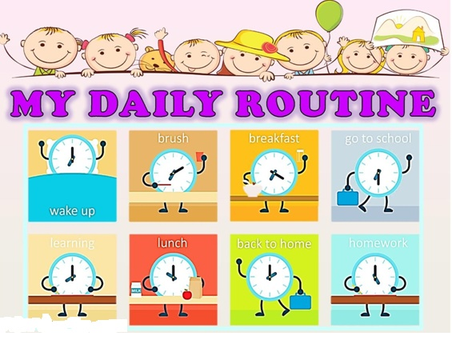

Брянск 2022
Рекомендована методическим Советом ФГБУ ПOО «БГУОР»
Протокол методического Совета № ___ от «___» ____________ 20____ г.
Разработчик:
Бурыкина С.В. – преподаватель иностранного языка
Материалы методической разработки адресованы студентам колледжей, училищ, а также учащимся школ и всем, кто заинтересован в изучении английского языка.
Настоящее учебное пособие имеет целью помочь студентам выработать навыки устной и письменной речи на основе тематически подобранных текстов, которые расширяют возможность работы над темой «Мой рабочий день».
Пособие состоит из разделов, включающих тематические тексты, лексику,
подлежащую активному усвоению, и упражнения, способствующие развитию навыков монологической и диалогической речи.
Данное пособие может быть использовано как в аудитории для выполнения заданий под руководством преподавателя, так и для самостоятельной работы студентов

Содержание

- Glossary. Лексический минимум по теме____________4
- My Daily Routine. Reading _________________________6
- Vocabulary Exercises _____________________________10
- Grammar Еxercises ______________________________12
- Appendices __________________________________________17
- Sources _________________________________________19

Glossary

wake up – просыпаться
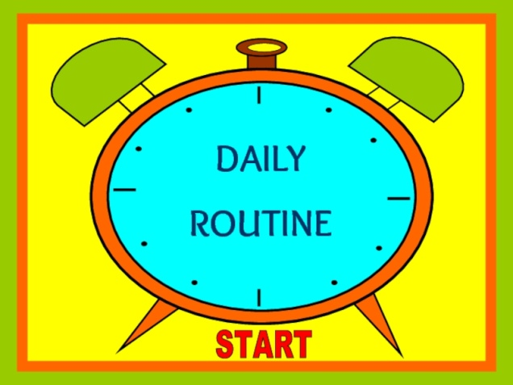
get up - вставать
have a shower - принимать душ
shave - бриться
dry yourself - вытираться
brush your teeth - чистить зубы
wash your face - умываться
rinse your face - ополоснуть лицо
get dressed - одеваться
comb your hair - расчесываться
put on make-up - наносить макияж
have breakfast - завтракать
have a cup of coffee - выпить чашку кофе
go to work - идти на работу
watch (TV) - смотреть (телевизор)
listen to the radio - слушать радио
read (the paper) - читать (газету)
have a bath - принимать ванну
brush your hair - расчесываться
go to bed - ложиться спать
sleep – спать
get undressed - раздеваться
put on a dress - надеть платье
take off a dress - снять платье
cook/make breakfast- готовить
read the news - читать новости
surf the Internet - сидеть в интернете
drink coffee - пить кофе
eat vegetables - есть овощи
go to work/school – идти на работу, в школу
drive a car - водить машину
get to work - приезжать на работу
start work – начинать работу
talk to clients - разговаривать с клиентами
go to the gym – ходить в тренажерный зал
go shopping – ходить по магазинам
go home – идти/ехать домой
get home - приходить домой
do homework – делать уроки, домашние задание
do housework – делать работу по дому
chat with friends - болтать с друзьями
meet friends - встречаться с друзьями
visit relatives - навещать родственников
feed the dog - кормить собаку
take the dog for a walk - выгуливать собаку
set the alarm-clock for 7 o'clock - заводить будильник на 7 часов
fall asleep – засыпать
have a rest — отдыхать
go to see smb – навещать кого-либо

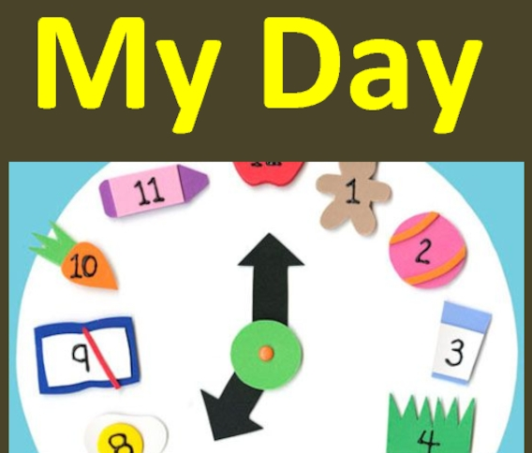

- Прочтите и переведите стихотворение:

I go shopping on Monday,
I do the cooking on Tuesday,
I do the washing on Wednesday,
I do the ironing on Thursday,
I clean the flat on Friday,
By the end of the week I am tired.
I have a rest on Saturday and Sunday
And I am good and full of life by next Monday.

- Read and translate the text. (Прочтите и переведите текст):
My Daily Routine
We all have some things we do every day or almost every day in a particular order. They are called “daily routine”. Let me tell you about my daily routine.
My typical day is quite busy, it begins at 6 o’clock in the morning when I wake up. When my alarm goes off, I turn it off, get up and make my bed. Then I take a shower, brush my teeth and do my morning workout. I do not exercise much in the morning, just a few simple exercises such as push-ups.
Usually, my mom makes breakfast for all of us, which is my parents and I. My older brother is a student and he lives in a dormitory. I have breakfast with my family. My father usually walks our dog, but when I have enough time, I like walking the dog myself.
After breakfast I go to school. I do not walk there because it is too far. I take a bus and get off by the school. It takes the bus about 15 minutes to get there, so I usually play games on my phone or watch YouTube videos. My classes start at 8 a.m. After the third lesson we have a break. My classmates and I go to the cafeteria where we have a cup of tea with a sandwich and chat.
After school, I take a bus home. Sometimes my friend’s father picks him up, and they give me a ride. At home I have lunch, then do the dishes. My mom works part-time and spends the morning hours at home. Usually, she goes to work at 2 pm. When my parents are at work I do the chores. I clean up the kitchen and my room, the living room if necessary, then I do the vacuuming in the hallway and feed the dog.
Then I just rest and do whatever I like. I go to the gym three times a week with my friends. So if it is a gym day, I go there. If it is not, I just watch TV or surf the Internet.
When my mom comes home, we cook together. While we are cooking, she might ask me about my day at school. My father returns from work a bit later. We have dinner together, then I do my homework. If I have enough time, I might watch a show, read a book or play a videogame. Sometimes we watch TV together. I am not a very outgoing person but once or twice a week I might go out with my friends. We love hanging out in the local part which is right next to the building where I live.

Normally, I do not stay up late, and go to bed at 10 or 11 o’clock in the evening. That is my daily routine.
- True or False (Верно/неверно):
- We all have some things we do every day or almost every day in a particular order.
- My typical day is quite busy, it begins at 7 o’clock in the morning when I wake up.
- I do a lot of sports in the morning, just a lot of simple exercises, such as push-ups.
- My father usually walks our dog, but when I have enough time, I like walking the dog myself.
- After breakfast I go to school. I do not walk there because it is too far.
- My classes start at 8.30 a.m.
- After the second lesson we have a break. My classmates and I go to the cafeteria where we have a cup of tea with a sandwich and chat.
- We love hanging out in the local part which is right next to the building where I live.
- Выпишите из текста следующие слова и выражения:
Определённый порядок, распорядок дня, напряжённый, просыпаться, выгуливать собаку, идти пешком, готовить, делать домашнюю работу.
- Выпишите из текста 5 глаголов и составьте с ними 5 предложений.
- Поставьте к тексту 5 вопросов.
- Составьте диалог, опираясь на текст. (не менее 18 реплик)

MY DAILY ROUTINE (2)
- У каждого человека есть свой обычный распорядок дня — daily routine. Это те дела, которые мы делаем ежедневно или очень часто. Жирным шрифтом выделены фразы, используя которые вы можете составить свой собственный рассказ о распорядке дня.

My daily routine 1
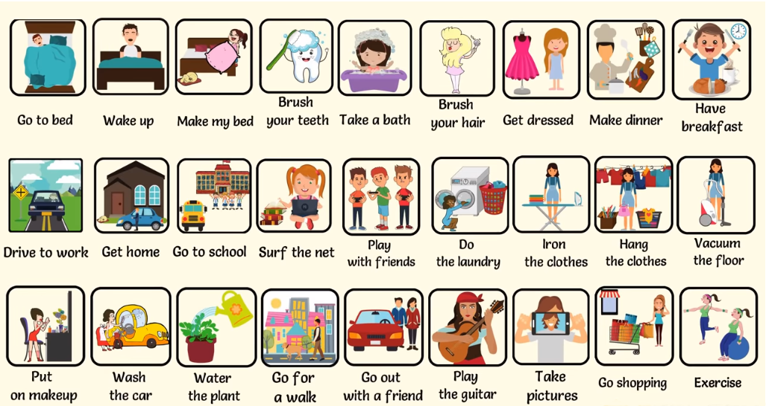
We all have our own daily routine. I want to talk about my typical day. Every morning I get up at 7 o’clock and make my bed. Then I go to the bathroom where I wash my face, have a cool shower and brush my long hair. My brother has short hair so he combs his hair. Then I do some exercises to feel great all day. I usually watch music clips on TV while I have breakfast. For breakfast, I like scrambled eggs and sandwiches with a cup of tea. Sometimes I put on some make-up. Then I take my school backpack and leave the house. My school is not far from home, so I go there on foot.
Our lessons begin at 9 o’clock and finish at around two or a little later. My friend and I love to chat a bit before going home. When I come home, I walk and feed my dog at first. Then I have lunch and rest for a while. I like reading books about teenagers, especially fantasy books. After that, I do my homework, tidy up the room, and go for a walk with friends.
In the evening I like playing computer games. I also check emails, chat with friends, surf the internet or watch a movie.
After my parents return home, we have dinner together and talk about the events of the day and plans for tomorrow. We dream about the weekend when we can escape the daily routine. I go to bed at eleven, but my parents love to chill out on the sofa and read books.

- Дополните предложения:
- Every morning I get up at ______
- Then I go to the bathroom where ___________
- Then I do _____
- I usually watch __________
- I take my ___________
2) Вставьте пропущенные слова:
1. . My school is not far from home, so I go there ___ 2. When I come ____, I walk and feed ____ at first. 3. I __ my homework, ___ the room, and ___ a walk with friends. 4. After my parents ____home, we _____ together. 5. I go to ___ at eleven.
______________________
do, bed, return, on foot, tidy up, have dinner , home, my dog,
3. Выпишите из текста время и напишите его словами.

My daily routine 2
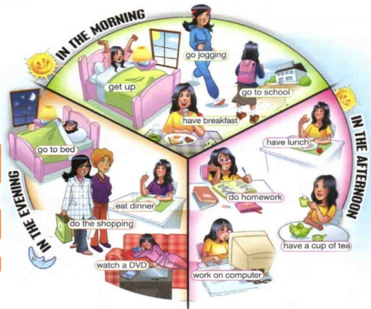
On weekdays, I usually get up at 6:30. I like to get up early to do my jogging in the park, so I get my pyjamas off and put on my sportswear. There is a very beautiful and quiet park not far from my home and I go jogging there every day, even on weekends. Then I go back home and have a shower. Then I get dressed and go to the kitchen for breakfast. My mother usually cooks breakfast, but sometimes I do it myself. I prefer a large cup of coffee and a sandwich, but my mother often cooks porridge. She believes that the porridge is the most healthy and useful breakfast for the whole day.
Then I shine my shoes and call my friend who lives next door and we go to school together. The school is quite close to our house. Lessons start at 9 o’clock and finish at two or three, it depends on the schedule. Then I come home and have lunch. After lunch, I have a little rest and then I start doing my homework. Usually, the homework takes me two hours. If mom asks me, I take the rubbish out or go grocery shopping for supper or do another simple daily routine.
Then I go for a walk with my friend and his dog. We go to the park and throw a ball, and the dog brings it back to us.
In the evening I have dinner with my family. We all get together, joke, have fun, discuss our family affairs.
I usually go to bed around eleven o’clock.
Прочтите и переведите текст. Ответьте на вопросы по тексту:
- When does the author's working day start?
- What does the author of the text do in the park every morning?
- What does the author of the text eat for breakfast?
- What time do the author's classes start?
- How long do the classes of the author of the text last?
- What time does the author go to bed?

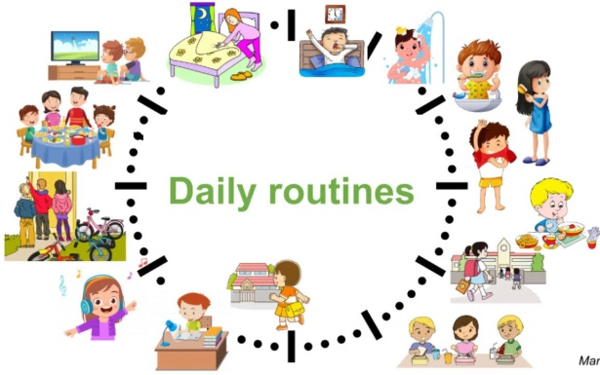
My daily routine (3)
Every day I usually do the same things such as going to school, tidying up the flat, preparing food, washing clothes and do some other daily routines. In the morning at 7 o’clock, the alarm wakes me up and I go to the bathroom. I have a shower, brush my teeth, then dry my hair. Then I make my bed and put on my school uniform. Usually, at this time I listen to my favourite music.
My mother normally cooks breakfast for the whole family. It can be porridge, spaghetti with sausages or just sandwiches. I also have a cup of coffee with milk. At eight o’clock I take my school bag and go to school. Classes begin at 8:30, and finish at about 3 pm. During breaks, we play and chat with friends.
After school, I go home, have lunch and rest for a while. We always have a lot of homework, so I try to do it faster. As a rule, it takes me about two hours to finish my homework. Sometimes I do some housework such as vacuuming, sweeping, washing, or hanging the clothes out to dry. Fortunately, nowadays we have many modern appliances that help us do our daily routine.
My parents return home at about seven o’clock. We always have supper together. We share all the news and I tell about the school and my friends. In my house, I usually do the dishes after supper.
Three times a week I go to the swimming pool. When I do not go to the swimming pool, I stay at home and play my favourite computer games or read books. In the evening I usually go for a walk with friends. At eleven o’clock I go to bed and usually fall asleep very quickly.
- Найдите в тексте следующие предложения и выпишите их:
- Утром в 7 часов меня будит будильник и я иду в ванную.
- Моя мама обычно готовит завтрак для всей семьи.
- Я также выпиваю чашку кофе с молоком.
- Занятия начинаются в 8:30 и заканчиваются около 15:00.
- Три раза в неделю я хожу в бассейн.
- Напишите 1 абзац текста в 3 лице единственного числа Present Simple.
- Выпишите из текста 7 существительных и образуйте множественное число.
- Выпишите из текста время и напишите его словами.

Лексические упражнения по теме «My daily routine»

Exercise 1. Вставьте слова get / go / have / come / iron / watch / buy / do / listen / take / read, так чтобы получились фразы, при помощи которых можно описать свой распорядок дня на английском, переведите получившиеся фразы.
1. ______________ the laundry  2. _______________ up  3. _______________ dinner  4. _______________ to bed  5. _______________ TV  6. _______________ home  7. _______________ breakfast  8. _______________ to work | 9. _______________ a book  10. _______________ to music  11. _______________ a shower  12. _______________ shopping  13. _______________ a newspaper  14. _______________ the clothes  15. _______________ dressed  16. _______________ lunch
Exercise 2. Распределите предложения, описывающие распорядок дня с профессиями людей. Первое предложение уже сделано:
- I work in a hospital.
- I speak with people from different countries.
- I speak three languages.
- I sell things.
- I work in a shop.
- I help sick people.
- I translate things.
- I work in a newspaper office.
- I work with doctors.
- I look after money.
- I write a lot.
Exercise 3. Сопоставьте слова и выражения с их переводом:
Do the laundry  Get up  Have dinner  Go to bed  Watch TV  Come home  Have breakfast  Go/ come to work  Read a book  Listen to music  Take a shower  Do / go shopping  Read a newspaper  Iron the clothes  Get dressed  Have lunch | Стирать  Вставай  Обедать  Идти спать  Смотреть телевизор  Возвращаться домой  Завтракать  Идти / приходить на работу  Читать книгу  Слушай музыку  Принимать душ  Ходить по магазинам  Читать газету  Гладить одежду  Одеваться  Oбедать

Exercise 4. Прочитайте и переведите фразы, описывающие распорядок дня. Заполните данными фразами таблицу.
I do this every day | I often do this | I rarely do this | I never do this

- wake up
- get up
- leave school
- have lunch
- make the bed
- have dinner
- read an interesting book
- read a comic
- sleep well all night
- work hard
- listen to music
- do (my) homework
- read a magazine
- go shopping
- do the morning exercises
- watch TV
- have a shower
- wash (my) face
- brush (my) teeth
- get dressed
- have breakfast
- go to school
- come home
- play with (my) brother
- read a newspaper
Exercise 5. Поставьте фразы из первой колонки предыдущего упражнения в хронологическом порядке, то есть в порядке того, как вы делаете это в течение дня. Начните с wake up!

Грамматические упражнения

по теме Daily Routine + Present Simple

Exercise 1. Раскройте скобки, используя Present Simple.
Roberto (1) __________ (start) his day at 8.00. He (2) __________ (have) breakfast in the kitchen with all the family. Roberto (3) __________ (like) orange juice, toast and milk. He always (4) __________ (have) an apple. After breakfast Roberto (5) __________ (make) his bed and (6) __________ (tidy) up his bedroom. He (7) __________ (get) ready for lessons. He mustn’t be late, as mother (8) __________ (be) very strict.
At 9.00 the Hanson kids (9) __________ (start) their lessons. At midday they (10) __________ (have) lunch. Then it’s sport time: they (11) __________ (love) playing basketball, in-line staking and skate-boarding.
Roberto and his brothers (12) __________ (not/have) dinner with their parents as their father is always late. Their mother (13) __________ (not/like) it very much. So, at weekends they (14) __________ (be) always together.

Exercise 2. Раскройте скобки, используя Present Simple.
Mary (1) __________ (wake) up at 7.00. Then she (2) __________ (get) up at 7.30 and she (3) __________ (go) to the bathroom. She (4) __________ (have) a shower, (5) __________ (brush) her teeth and (6) __________ (comb) her hair. Afterwards she (7) __________ (have) breakfast. Ten minutes later she (8) __________ (take) her bag, (9) __________ (kiss) her mother and (10) __________ (catch) a bus to school with her friend Diana. They (11) __________ (start) school at 9.00. They (12) __________ (not/have) lunch at the school canteen. At three o’clock they (13) __________ (return) home.
In the afternoon, she (14) __________ (study) her lessons and (15) __________ (ride) her bicycle. In the evening she (16) __________ (help) her mother prepare the dinner. After dinner she (17) __________ (watch) TV, her mother (18) __________ (read) a magazine and her father (19) __________ (go) to bed earlier since he (20) __________ (be) always the first in the family to get up.

Exercise 1. Прочтите и переведите текст:
Greg’s Daily Routine
Greg is an American boy. He lives in Arlington, Texas. He lives with his family in a modern house. He is eleven years old and he has got an older brother, Alex, and a younger sister, Emma.
He starts his day at about half past six. He gets up, goes to the bathroom, takes a shower, brushes his teeth and get dressed. Then he has breakfast and at a quarter to seven he leaves home and catches the bus to school.
Classes begin at half past seven. He usually has lunch at the school canteen at half past twelve. After school, at a quarter past five, he goes home. There he does his school homework and when he finishes it he helps his Mum laying the table. At half past seven the family dines together.
Greg is a very helpful boy, so he helps his mother cleaning up everything after dinner.
He usually watches TV for a while after dinner and at about ten o’clock the most he brushes his teeth again, puts on his Spider Man pajamas and goes to bed. His parents always kiss him good night before he gets asleep. Greg is a very happy boy!

Exercise 2. True or False. (верно/неверно)
- Greg is an American boy.
- Greg lives in a modern flat.
- Greg is eleven years old.
- Greg has got two brothers.
- Greg wakes up at eight o’clock.
- Greg walks to school.
- Greg classes begin at half past eight.
- Greg and his family have dinner at half past seven.

Exercise 3. Match the antonyms: (найдите антонимы)

modern  older  starts  leaves  begin  together  helpful  happy | enters  alone  end  old-fashioned  unhappy  younger  finishes  unhelpful

Exercise 4. Answer the questions (ответьте на вопросы)

- Where does Greg live?
- What’s his sister’s name?
- What time does he wake up?
- Does he have breakfast at home?
- What time does he leave home?
- Where does he have lunch?
- When does he return home?
- Does he do his homework at school or at home?
- Is he a helpful boy?

Exercise 5. What about you? What’s your daily routine like? (опишите свой день)

Упражнение 1. Используя следующие карточки, расскажите о распорядке дня Джейми, Мелани, Анны, Джессики и Паула.
1. Расскажите о распорядке дня Джейми.
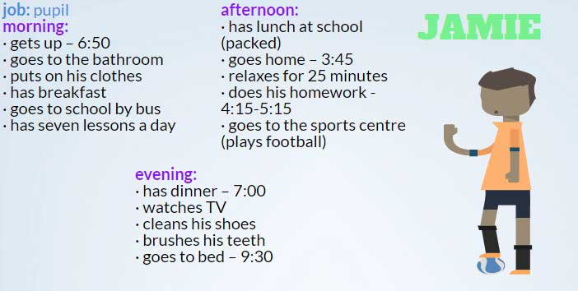
2. Расскажите о распорядке дня Мелани.
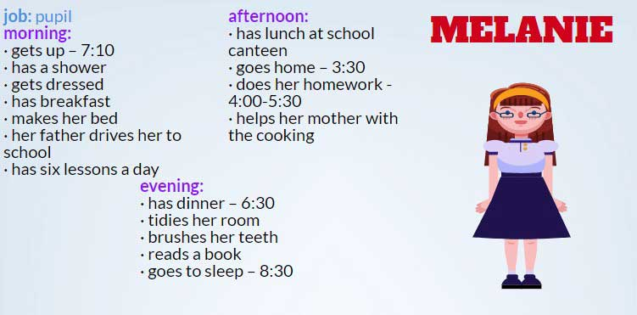
3. Расскажите о распорядке дня Анны
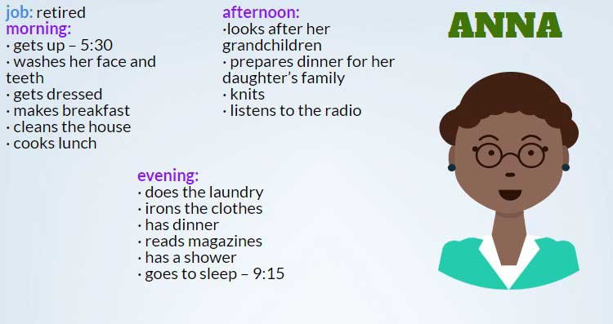

4. Расскажите о распорядке дня Джессики.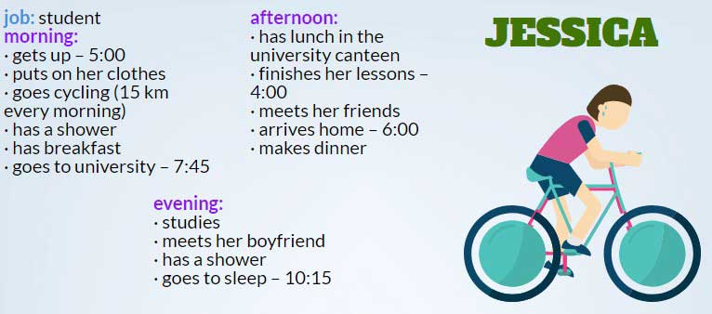5. Расскажите о распорядке дня Паула.
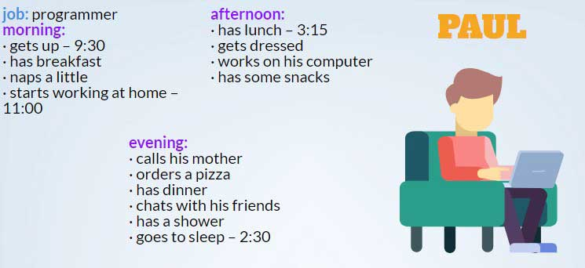
Упражнение 2. Ответьте на вопросы
- What time do you get up?
- Where do you have breakfast?
- What do you have for breakfast?
- Do you go to school in the morning or in the afternoon?
- What time do you have lunch?
- What do you do in the afternoon?
- When do you do your homework?
- Do you have a shower before going to bed?
- Do you watch TV at night?
- What is your favorite TV programme?
- What time do you go to bed?

Упражнение 3. Используя карточку, расскажите о своем распорядке дня на английском.
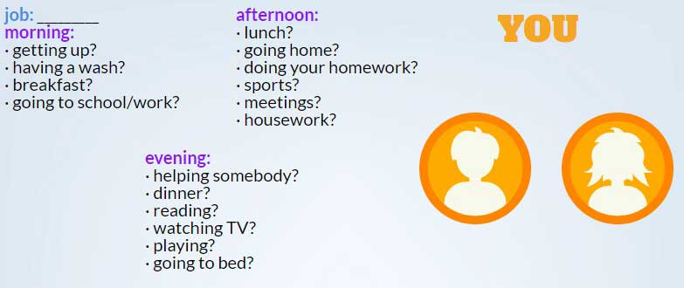

Appendices
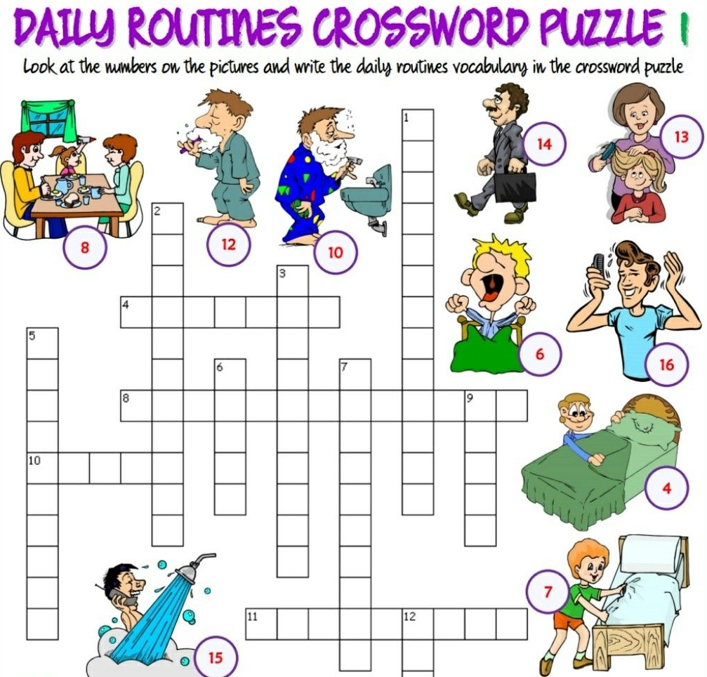
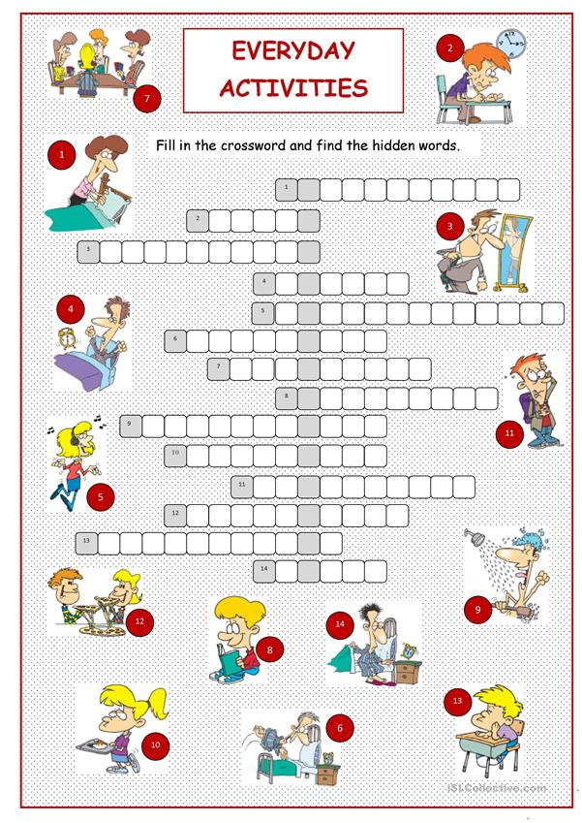
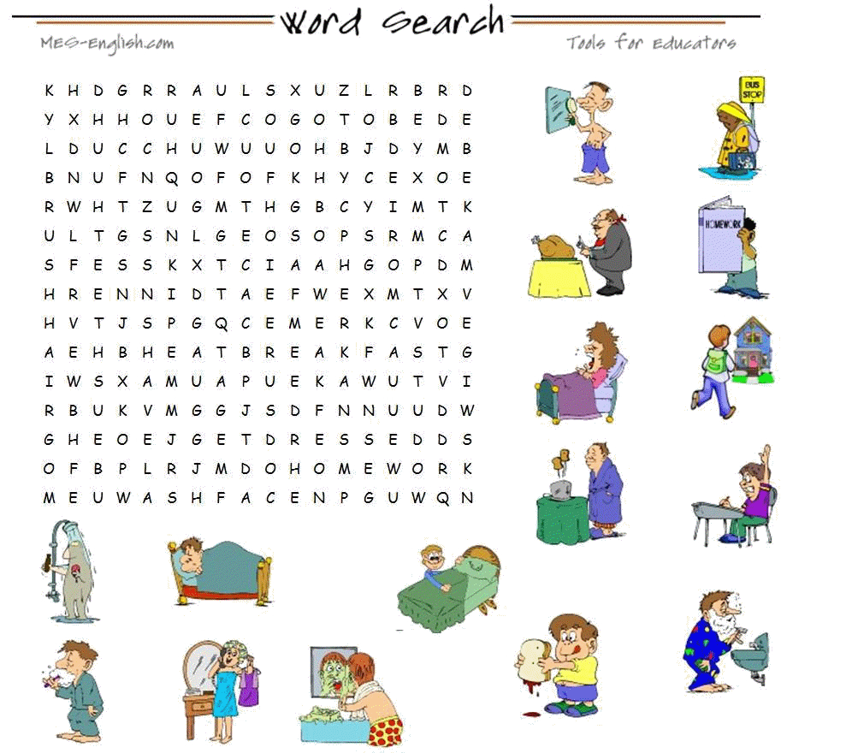

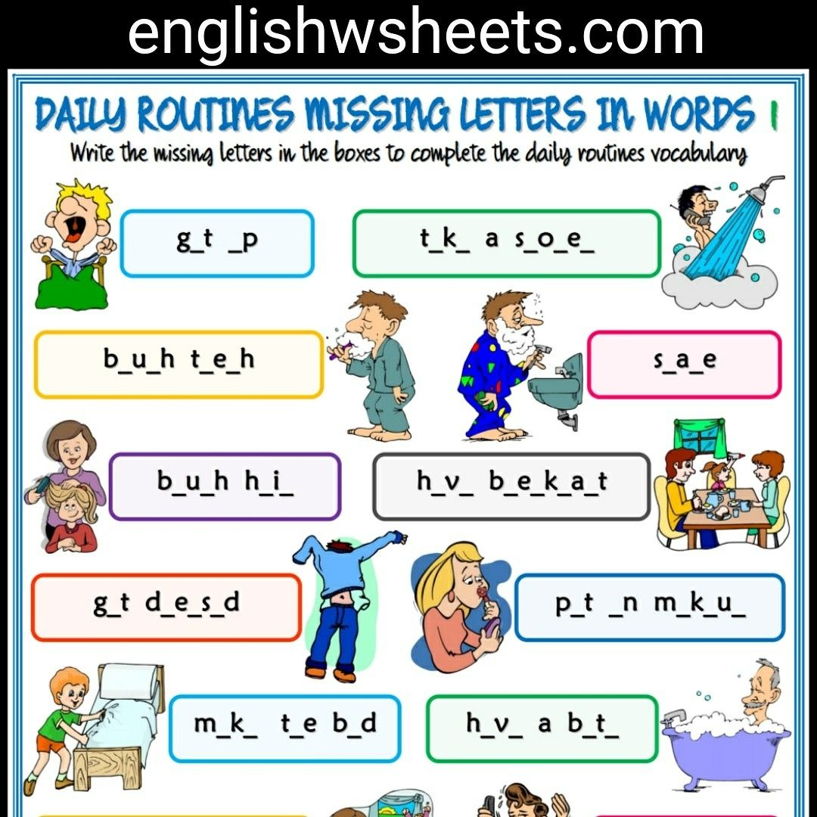
Sources

- http://grammar-tei.com/daily-routine-rasporyadok-dnya-uprazhneniya-po-anglijskomu-yazyku-present-simple/
- https://yandex.ru/images
- https://englishearly.ru/my-working-day/
- https://wt-blog.net/anglijskij-jazyk/teksty-na-anglijskom-jazyke/tema-my-working-day-tekst-moj-rabochij-den.html

