Федеральное государственное бюджетное учреждение
профессиональная образовательная организация
«Брянское государственное училище (колледж) олимпийского резерва»

КОМИССИЯ ДИСЦИПЛИН
СОЦИАЛЬНО-ГУМАНИТАРНОГО ЦИКЛА

EDUCATION
МЕТОДИЧЕСКАЯ РАЗРАБОТКА ПО АНГЛИЙСКОМУ ЯЗЫКУ


БРЯНСК 2017
Рекомендована методическим Советом ФГБОУ СПО «БГУОР»
Протокол методического Совета № ___ от «___» ____________ 20____ г.

Разработчик:
Сёмина К.С. – преподаватель иностранного языка

Материалы методической разработки адресованы студентам колледжей, училищ, а также всем, изучающим английский язык
Учебное пособие для развития умений и навыков чтения и перевода текстов по специальности, расширения лексического запаса студентов в области профессиональной терминологии. Кроме того, пособие нацелено на развитие навыков профессионально ориентированной устной речи. Разработанная система предтекстовых, текстовых и послетекстовых упражнений, а также серия творческих заданий направлены на решение познавательно-коммуникативных задач в процессе чтения, формирование умений и навыков чтения и возможного использования полученной информации в будущей профессиональной деятельности.

2 35

Список источников:
- https://en.islcollective.com/
- https://globalofse.wordpress.com/united-kingdom/
- http://www.ibe.unesco.org/Countries/WDE/2006/NORTH_AMERICA/United_States_of_America/United_States_of_America.htm
- Bogoroditskaya V.N., Khrustalyova L.V. The World of Britain. М.: Издательство «Версия», 2000.
- Education in Great Britain: Учебно-методическое пособие. / Сост.: Е.И. Бояринцева, Т.П. Руденко. – Омск: Изд-во ОмГУ, 2004. – 76 с.
- Занина Е.Л. ЕГЭ Английский язык. Устные темы. М.: Айрис-пресс, 2010 – 272 с.

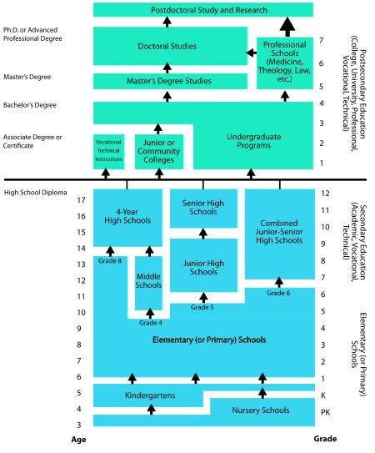
Educational System in the USA

CОДЕРЖАНИЕ:
Glossary. Лексический минимум по теме…………….….. | 4
Text 1. History of Education ………………………………. | 7
Text 2. State Education in Britain………………………… | 12
Text 3. Schools in Britain………………………………….... | 14
Text 4. Britain’s Universities…………………………..….. | 16
Text 5. Education in the USA……………………………… | 18
Texts for extra reading………………………………………. | 20
Text 6. Education in Russia…………………………………. | 25
Exercises ……………………………………………………. | 26
Let’s talk ……………………………………………………. | 28
Appendices……………………………………………..….… | 32
Sources ………………………………………….…….…….. | 35

34 3

Glossary
a state school  a private school  a public school  a boarding school  a secondary school  a grammar school  a technical school  a comprehensive school  primary education  infant school  junior school  a pupil (= AmE a student)  a student  a college of further education  a further education establishment  a subject  a term  a lecture  technical courses  a trade  an exam (an examination)  to charge fees for education  tuition fee  free nursery school education  to take final examinations  to take a school leaving examinations  a national system of education  4 33 | государственная школа  частная школа  государственная школа  школа – интернат  средняя школа  грамматическая школа  техническая школа  общеобразовательная школа  начальная школа  начальные классы  средние классы  ученик  студент  колледж дальнейшего образования  учебное заведение дальнейшего образования  предмет  семестр  лекция  технические предметы  профессия, ремесло  экзамен  брать деньги за образование  плата за обучение  бесплатное дошкольное обучение (подготовительная школа)  сдавать выпускные экзамены  сдавать выпускные экзамены (в школе)  национальная система образования
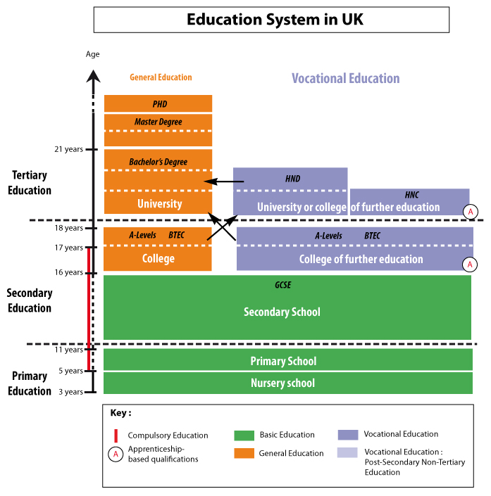


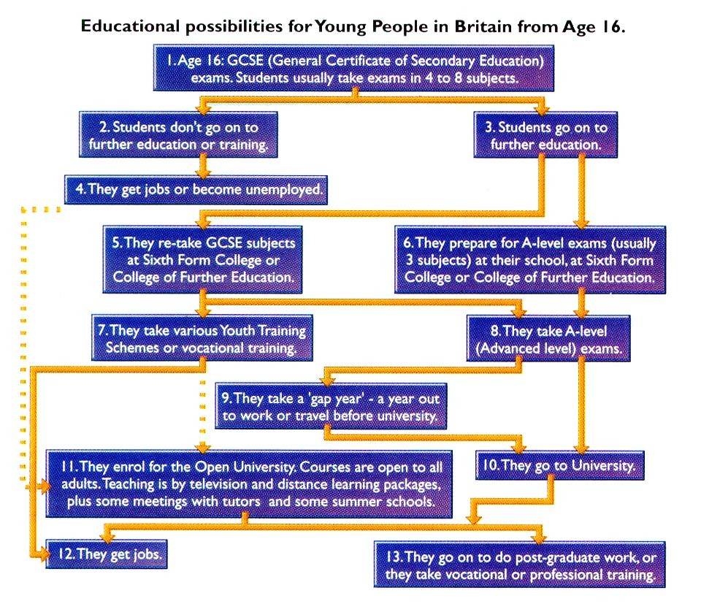

32 5
ordinary level  advanced level  a general certificate of education  a general certificate of secondary education  free  fee - paying  elementary school  elementary education  secondary education  an intermediate school  a junior high school  a senior high school  the upper classes of high school  to leave school  a classes  a lesson  a form (a grade)  a classroom  to enter a university (a college)  to graduate from a university (a college)  higher education  a university  a college  a technical school  a vocational school  to teach  to study  to receive a grant  undergraduate  freshman | обычный уровень  продвинутый уровень  аттестат об общем образовании, экзамен на аттестат об общем образовании  общий аттестат о среднем образовании, экзамен на аттестат о среднем образовании  бесплатный  платный  начальная школа  начальное образование  среднее образование  средние классы (первая ступень средней школы)  старшие классы (вторая ступень средней школы)  старшие классы средней школы  окончить школу  занятие  урок  класс  кабинет  поступить в университет (колледж)  окончить университет (колледж)  высшее образование  университет  колледж  техникум  профессиональное училище  преподавать  учить (изучать)  получать стипендию  студент последнего курса  студент-первокурсник
Bachelor degree  Master degree  Bachelor /Master of Science  Bachelor /Master of Arts  to get Bachelor degree/ Master degree  a teacher  a lecturer  teacher's diploma  diploma in education  to award / confer / present a diploma  pass degree  honours degree  graduation paper /graduation work / research / thesis  residence hall / dormitory  full-time education  extra-mural tuition  a faculty  a department  sports department  pedagogical department  Bryansk State College of Olympic Reserve  Lesgaft National State University of Physical Education, Sport and Health  Bryansk State University named after Academician I.G. Petrovsky  6 31 |  | степень бакалавра  степень магистра  Бакалавр/магистр (естественных) наук  Бакалавр/магистр гуманитарных наук  получить степень бакалавра/магистра  учитель  преподаватель  диплом учителя  диплом педагога  выдавать диплом  диплом без отличия  диплом с отличием  дипломная работа (ВКР)  общежитие  очное обучение  заочное обучение  факультет  отделение  спортивное отделение  педагогическое отделение  Брянское Государственное училище олимпийского резерва  Национальный государственный университет физической культуры, спорта и здоровья имени П.Ф. Лесгафта  Брянский государственный Университет имени академика И.Г. Петровского
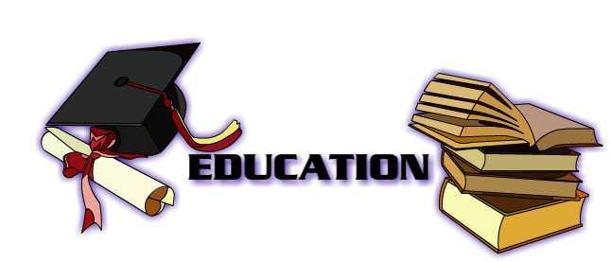
Search the following vocabulary in the Word puzzle and find Russian equivalents.

- BOARDING SCHOOL
- CLASSROOM
- COLLEGE
- FRESHMAN
- HIGH SCHOOL
- KINDERGARTEN
- LECTURER
- NURSERY SCHOOL
- PLAYGROUND
- PRIMARY SCHOOL
- PROFESSOR
- SECONDARY SCHOOL
- STAFFROOM
- TEACHER
- UNIVERSITY

N L A U I H R Z I O I A U Y L
N B O A R D I N G S C H O O L
P U S O C E E J I Y H R O P Q
R T R T H P J U T J E H D R P
O E N S A C D I J S C H N I V
F A P K E F S O I S H B U M O
E C J H A R F H Y D R L O A N
S H M A E K Y R G L I H R R A
S E R V V R A S O I Y R G Y M
O R I I C D B M C O H O Y S H
R N R W N T S P H H M F A C S
U R C O L L E G E A O L L H E
O I C L A S S R O O M O P O R
N E T R A G R E D N I K L O F
S R E R U T C E L Z V R H L R

Craig : Actually, it’s not that good. I can read but I can’t speak very well. I haven’t had a lot of chance to practice.
Rachel : I see. Talking with other people is very important.
Craig : Yes, but I still don’t have many friends here yet.
Rachel : I’m having a party tonight at my apartment. You should come.
Craig : Oh thanks for inviting me. I’d love to come.


Shawn : Hi Kim.
Kim : Hey Shawn, good to see you again.
Shawn : How have you been?
Kim : OK, I didn’t sleep much last night though. I stayed up until 2AM studying for an exam.
Shawn : I was up late last night too. The semester is almost over. Ive had exams all week.
Kim : Are you going back to California after you graduate?
Shawn : I think so. After I graduate I’ll probably go back home and try to get a job.
Kim : Do you know where would you like to work?
Shawn : Not yet, but I want to be an English translator.
Kim : That’d be really cool. I’d like to be a translator too, but I don’t think my English is good enough.
Shawn : Don’t worry about that. Your English is better than most of my classmates.
Kim : Thanks. Where are you going now?
Shawn : I’m going to study at the library. I have to take an exam tomorrow.
Kim : Me too. How late does the library stay open?
Shawn : I think it’s open until 11:30PM.
Kim : OK, Good luck.

Shawn : You too.

What do you think about these sayings?
Education is the best provision for old age.
Aristotle.
One's work may be finished some day,
but one's education – never!
Alexandre Dumas.

Read the text and translate it using a dictionary. Write out all the unknown words

HISTORY OF EDUCATION

As long as we live we continue to learn, and the education we receive when we are young helps us to continue learning. We are taught to read and write, and are taught many of the essential facts about the world and shown how to sort them out.
The first teachers were fathers and mothers, but very early in the history of man children began to be taught by other people. It is thought schools first started in Egypt 6,000 years ago, and that it was the invention of writing, which made them necessary. Reading and writing were quite different from the skills used in everyday life, and writing made it possible to store up knowledge, which grew with each generation. Only the sons of nobles attended the first Egyptian schools, which taught reading, physical education and good behavior.
In ancient India the priestly caste decided what should be taught to each of the four castes, or groups, into which people were divided. Only the priestly caste was allowed to learn the Hindu scriptures.
In China, until the 19th century, education was organized according to social classes, and consisted largely of learning the scriptures by heart.
A clear example of the way in which even neighbouring peoples produce different types of education comes from ancient Greece. Sparta and Athens were two Greek states. The Spartans, a hard and warlike people, gave a purely military education. At the age of seven all boys of noble families were taken from their homes and were sent to live in groups. They were kept under a very strict discipline and were taught hunting, military scouting, swimming and the use of weapons. The Spartan despised literature, and some people think they could not even read.
30 7
At the very same time, also for the nobles only, the Athenians were building what we call a liberal education - one that helps a man to develop all sides of his nature, helps him to make and appreciate beautiful things and helps him to find the best way of life. They thought it was important to educate the body as well as the mind, and had a programme of physical training, which consisted of running and throwing the discus. As time went on Athenian education paid special attention to reading, writing and literature and these were taught by a special teacher, known as the "grammatist". Common people were not educated, they were trained in craftsmanship, workmanship, trades. Greek philosophers or thinkers always discussed what education should try to do and what it should include. Since those days Greek ideas have influenced European education.
The Romans were very good at organizing, and they were the first people to have schools run by the government free of charge. Throughout their great empire there was a network of these schools which provided for three stages of education. At six or, seven all boys (and some girls) went to the primary school, where they learned "three R's": reading, writing and arithmetic. Most children were not taught more than this but at 12 or 13 boys of the rich families went on to the "grammar" school to study the Greek and Latin languages and their literature. At 16, young nobles who wanted to enter politics or the service of their country went to the schools of rhetoric to be trained in rhetoric, or public speaking.

8 29
Read, translate and act out the dialogues

Michael: Examinations do more harm than good!
Judy: I agree. We spend so much time studying for examinations that we don’t have enough time for fun!
Helen: I don’t agree. Without exams, no one would do any study. We would soon forget everything.
Sunny: That’s right. The only time I do any work is when there’s going to be an exam! That’s true of everyone, isn’t it?
Selena: No, I don’t think so. Many people work all the time, and they remember that they learn. That’s better than doing no work for weeks and then working all night before the examination. If there were no exams, more people would work like that, don’t you agree?
Helen: No, I don’t think so. I think many people wouldn’t do any work at all. I know I wouldn’t.
Sunny: Of course not. Besides, without exams, how would an employer decide whether to give us a job?
Michael: The teachers could write reports about us. Examinations can be unreliable, don’t you think so? Our teachers know as well, don’t they?
Helen: Yes, they do. That’s why I would rather have an examination!


Rachel : Craig, what do you do for work?
Craig : I’m still a student.
Rachel : What school do you go to?
Craig : Boston University.
Rachel : That’s a good school. What do you study?
Craig : I’m studying English, math, and history. My major is English.
Rachel : How long have you been studying English?
Craig : More than six years.
Rachel : That’s a long time.
Craig : Yeah, I started to learn English when I was in high school.
Rachel : No wonder your English is so good.

- Where did you go to school? Do you think it was a good school?
- Do you plan to go to university? What will you study?
- What is (was) your favourite subject? Why do (did) you like it?
- What are the qualities of a good teacher? Of a good student?
- Once you graduate, should you stop learning? How can you continue to learn?
- How much homework or papers do students need to do? How much free time do they have?
- Is studying expensive in your country? What are the costs?
- Do you think it is easier to learn as a child or as an adult? Explain your view.
- Does education guarantee a good job?
- Which languages are taught in school? Is it difficult to learn to speak them well? Why?
- ‘I’d rather start making money at 16 than continue studying.’ Do you agree?
- ‘Most of what you learn in school is useless’. Do you agree?
- ‘You don’t need to go to school to be smart. I can teach myself.’ Do you agree?
- ‘Going to school is a complete waste of time.’ Do you agree?
- Which is more important: the skills you learn in school or in real life? Explain.
- Would you like to study abroad? Where? Why?


Answer the questions
- Where did schools first start? What made them necessary?
- How was education organized in China until the 19th century?
- What kind of education was given to children in Sparta?
- Were the Athenians building a liberal or military education?
- Were the Romans the first people having free of charge schools?
Fill in the gaps using to be, to have в Present Simple
- The first teachers ... fathers and mothers.
- The Romania ... schools run by the government free of charge.
- First year of elementary school is called “Grade 1”.
- We begin education when we ... young.
- They ... good ideas concerning education.
Translate the sentences with “there + to be” construction
- There were schools for nobles only.
- There are many essential facts that should be studied.
- There was a military education in Sparta.
- There are many different types of education.
- There was a liberal education in Athens.

28 9
What do you know about education? Let’s find it out!
Children who study at school are:
a. puppets
Class classmate examiner learner principal pupil coach graduate lecturer professor tutor
b. pupils
c. puppies

The place or class to prepare children aged five for school:
a. asylum
b. childhood
c. kindergarten

A small white or coloured stick for writing on the board
a. crayon
b. plaster
c. chalk

A book that contains the list of students’ names:
a. account book
b. school book
c. school register

The place in a school where food and drink are served:
a. canteen
b. dining room
c. buffet

A school where children can live during the school year:
a. boarding school
b. night school
c. schoolyard

An area of knowledge studied in a school or college, e.g. biology, maths, etc.:
a. matter
b. subject
c. topic
10 27

Match each person from the list with a suitable description. Use each name once only

- Someone who teaches at a university. ...............
- Someone who has a college degree................
- The head of a school................
- Someone who studies at primary or secondary school...........
- The most important teacher in a university department.........
- Someone who teaches one student or a very small class..........
- Someone in the same class as yourself................
- Someone who trains a sports team................
- Someone who writes the question papers of an examina tion…..
- Someone who drives but has not yet passed a driving test.......

Use the word in capitals at the end of each line to form a word that fits in the space in the same line
School report
Margaret started English Literature this term, and I am afraid that her (1) ............ to the subject has not been entirely (2) ..... She has not shown much enthusiasm, and does not always pay (3) ........ in class. Her assignments are often (4) ......., because she is so untidy, and because of her (5) .......... to check her work thoroughly. She failed to do any ......... before the end of term test, and had poor results. She seems to have the (7) ............ idea that she can succeed without studying. She has also had many (8) .......... and has frequently arrived late for class. This has resulted in several severe (9) ............. Although Margaret is a (10).............student in some respects, she has not had a satisfactory term. | INTRODUCE  SUCCESS  ATTEND  READ  FAIL  REVISE  MISTAKE  ABSENT  PUNISH  GIFT
Когда дети заканчивают школу, они должны пройти Единый государственный экзамен (ЕГЭ). Они представлены в виде стандартизированных тестов.
Высшее образование подразделяется на бакалавриат и магистратуру.
Бакалавриат - первый уровень высшего образования, который является базовым и длится 4 года. Магистратура – это второй уровень высшего образования, с углубленной, профспециализацией. Срок обучения в магистратуре для граждан, получивших диплом бакалавра, составляет – 2 года.
До 1990 года длительность школьного образования составляла 10 лет, но с 1990 школа длится 11 лет. Образование в государственных школах бесплатное. Учащиеся мужского и женского пола имеют равные права на всех стадиях образования.

EXERCISES

Choose the most suitable word or phrase underlined in each sentence
- Jack decided to take a course / lesson in hotel management.
- Sheila always got good marks / points in algebra.
- After leaving school, Ann studied / trained as a teacher.
- Peter decided not to go in / enter for the examination.
- My sister learned / taught me how to draw.
- I can't come to the cinema. I have to read / study for a test.
- In history we had to learn a lot of dates by hand / heart.
- I hope your work will improve by the end of course / term.
- Martin failed / missed his maths exam and had to sit it again.
- If you have any questions, raise / rise your hand.

26 11
Copying from books, notes or another student’s paper during a test or exam:
a. cheering
b. cheating
c. chatting

When you do not pass a test or exam you…:
a. fail

b. faint
c. fall

A talk given to teach students a particular subject, often as part of a university course:
a. lecture
b. lesson
c. class

The person who is in the same group as you at college
a. scholar
b. companion
c. groupmate

How do you call the special set of clothes worn by children in some schools?

What’s the name of the list which shows the times at which subjects are taught at school/college/university?

What’s the name of the short period of time between lessons during which students can relax or eat some snacks?

What’s the word which means “one of the 2 periods in the year during which classes are held in colleges, universities, etc.”?

Read the text, pay attention to the topical words and do the tasks.
STATE EDUCATION IN BRITAN
All state schools in Britain are free, and schools provide their pupils with books and equipment for their studies. Nine million children attend 35, 000 schools in Britain. Education is compulsory from 5-16 years. Parents can choose to send their children to a nursery school or a pre-school play group to prepare them for the start of compulsory education.
Children start primary school at 5 and continue until they are 11. Most children are taught together; boys and girls in the same class.
At 11 most pupils go to secondary schools called comprehensives which accept a wide range of children from all backgrounds and religious and ethnic groups. Ninety per cent of secondary schools in England, Scotland and Wales are co- educational.
At 16 pupils take a national exam called `GCSE` (General Certificate of Secondary Education) and them they can leave school if they wish. This is the end of compulsory education.
Some 16-years-olds continue their studies in the sixth form at school or at a sixth form college. The sixth from prepares pupils for a national exam called `A` level (Advanced Level) at 18. You need `A` levels to enter a university. Other 16-years-olds choose to go to a college of further education to study for more practical (vocational) diplomas relating to the world of work, such as hairdressing, typing or mechanics.
Universities and colleges of higher education accept students with `A` levels from 18. Students study for a degree, which takes an average three years of full- time study. Most students graduate at 21 or 22 are given their degree at a special graduation ceremony.

Find English equivalents to the following words:

бесплатное, обязательное, совместное, посещать, дошкольное образование, среднее образование, высшее образование, окончить школу, окончить институт, получить диплом, дневное обучение,
12 25
6 Students alone are responsible for their progress in a course. They must seek help, either with the professor or in a lab, if they need help with the work.
7 Any student who has the ability and the desire may apply to college.

Translate into English

ОБРАЗОВАНИЕ В РОССИИ
В России образование разделено на несколько этапов: общее образование, среднее специальное, высшее образование и дополнительное образование.
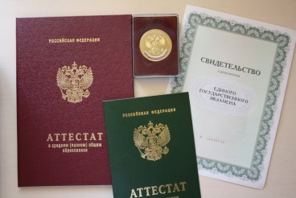
Общее образование направленное на развитие личных качества, базовых знаний и навыков, подразделяется на 4 группы: дошкольное, начальное, основное общеее и среднее общее. Дети в возрасте от двух месяцев до 7 лет могут находиться в дошкольных учреждениях (яслях и детских садах). Дети в возрасте от шести с половиной до восьми лет начинают ходитть в начальную школу. Это обязательная ступень общего образования и она длится 4 года. Следующий этап обучения – основное общее образование – оно длится 5 лет. После этого ученики могут получить поступить в средние учебные заведения, получив аттестат о . Или ученики могут отучиться еще два года и получить аттестат о.. После чего можно поступать в высшие учебные заведения.
Школьный год начинается 1 сентября и заканчивается в мае. Он делится на 4 четверти. Школьная программа единая для всех. Это значит, что школьники не могут выбирать, какие предметы учить.
9. If you are having difficulty with a class, schedule an appointment to see the teacher for help. The teacher will be glad to help you.
10 Students must bring a note from a parent explaining any absence or tardiness.
11 The only acceptable excuse for absence is personal illness, a death in the family, or a religious holiday. It is illegal to stay home from school for any other reason.
12 When a teacher asks a question and does not name a particular student to answer it, anyone who knows the answer should raise one’s hand.
College
1 A student who receives a failing grade in a course usually needs to repeat the course.
2 Students are expected to work hard in their courses.
3 Students' work is not discussed with parents without the students' permission.
4 After taking the required courses in their major,students may select their other courses.
5 All students are considered equal in the classroom and are judged only by the quality of their work.

24 13
степень, единая школа, принимать, продолжать, выбирать, диплом о средне- профессиональном образовании.

Match each of these worlds from the text with the correct definition:

- compulsory | - to finish university
- co- educational | - must do
- degree | - qualification from a university
- graduate | - boys and girls study together

Finish these sentences:
a. The school- leaving age Britain is…
b. Pupils go to… school before secondary school.
c. There are… schools for the under- 5s
d. The national exam at 16 is…
e. The national exam at 18 is…
f. Universities are part of…

Underline any differences between your system of education and the British system.

Answer the questions:
a. Are all state schools in Britain free?
b. Do schools provide their pupils books and equipment?
c. Is education compulsory?
d. When education is compulsory?
e. When do children start school?
f. What does the world ‘co- educational’ mean?
g. How is national exam at 16 called?
h. How is national exam at 18 called?
i. What degree do pupils need to enter university?
Read the text, retell it and do the tasks.
SCHOOLS IN BRITAIN

All children and young people between the ages of 4 or 5 and 16 must receive fulltime education in Britain.
At the age of five all children go to infant school and stay there until they are seven. Then they go to junior school where they study arithmetic, reading and composition, which are all tested subject. History, Geography, Nature Study, Art and Music, Physical education are also included into the timetable.
At 7 and 11years old teachers measure children’s progress in each subject. Pupils are streamed according to their ability to learn into A, B, C and D streams.
Infant and junior schools are the stages of primary education. To receive secondary education most children go to comprehensive school. The large majority of schools teach both boys and girls together. The Curriculum consists of English, mathematics, science, history, geography, technology, music, art, physical education and, for older pupils, a modern language. The young people stay at school till they are 16. Their years at secondary school may lead to General Certificate of secondary education (GCSE)* examinations. They are taken by students all levels of ability in any of a range of subjects.
16 is a crucial age when young men and women have to decide whether to stay at school, to go on to a college, to look for a job, or to start a Young Training programme.** Those not staying at school or going on to college after the age of 16 normally leave when they have completed their GCSE examinations. Those who choose to stay on at school after GCSE usually study for further years for «A» (advanced) level exams in two or three subjects.
Some comprehensive schools, however, do not have enough academic courses for them. Students can move either to a grammar school*** or to a sixth-year college**** to get the courses they want.
The «A» level exam is taken at the age of 18, and is the main standard for entry to university education and to many forms of professional training.
14 23
These are the rules for attending school in the United States. Indicate whether they are also true in your country by putting a check (+) or (-) in the appropriate column:
Rule | true (+) or  not true (-) in Russia
Kindergarten through to high school
1 Always refer to a teacher title and last name: Dr. Walker, Mr. Fields, Mrs. Ramirez, Professor McGuinness (never call a teacher "Teacher.")
2 Arrive to class on time or a little early.
3 Raise your hand when you want to ask a question.
4 You may speak to the teacher from your desk while you are seated.
5 When you are absent, you must make up the work you have missed. Ask either the teacher or a classmate for the work
6 If you expect to be away from school because of an emergency, tell your teacher in advance and ask for the work you will miss.
7 All assignments you hand in must be your own work.
8 Never cheat on a test.

requirements to mid-term and other examinations, and the explanations as to grading policy.
An important aspect of academic behavior in the USA is the attitude towards what is called cheating in the classroom, when doing assignments, during quizzes, tests, and exams. Giving unauthorized prompts to your fellow students, using "cribs" and other unauthorized materials, copying other students’ papers and assignments and trying to pass them off as your own, all other cases of plagiarism when, for instance, in her or his paper a student copies whole passages or pages from a coursebook or a scholarly book without citing the source - all these and other similar kinds of behavior are considered as academic cheating. They are treated as a crime. They are absolutely inadmissible. At best the students found guilty of such behavior will be suspended, but quite often dismissed from the university for good. A special record of it may prove a serious obstacle in the student`s future career.
Schools in the United States use their own grading system. However, most grades are either letter grades (А, В, С, D, F) or number grades. (Please, note that in some schools the letter/number grade may vary by one or two points).
Letter Grade Number Equivalent Meaning
A 90-100 Excellent
В 80-89 Good
C 70-79 Average Passing
D 60-69 Poor
F 0-59 Failing

What grading system is used in your country? How does it compare with grading in the United States?

Here are the grades an American student received. What kind of a student is he? In which areas does he need to improve?
English C /Math В /Science D /Social studies В /Physical education A /Spanish F
22 15
*GCSE (General Certificate of secondary education) – аттестат о среднем образовании
** Young Training programme – программа профессионального обучения молодёжи
*** Grammar school – a type of school preparing for university
****Sixth-year college – подготовительный колледж

Find English equivalents in the text:
Все дети и молодые люди; получить полное образование; в пятилетнем возрасте; до семи лет; предметы, подлежащие тестированию; природоведение; физвоспитание; проверить и оценить успехи детей; детей делят на потоки в соответствии с их способностями к учебе; степени начального образования; чтобы получить среднее образование; подавляющее большинство школ; учебный план; современный язык; экзамены на аттестат о среднем образовании; решающий возраст; решать, остаться ли в школе; пойти в колледж; искать работу; начать заниматься по программе профессионального обучения молодежи; по двум или трем предметам; курс по желанию; главное условие для поступления; университетское образование; профессиональное образование.
Answer the following questions:
- Is education compulsory in Great Britain?
Between what ages must British children and young people receive full-time education?
- What stages does the primary education consist of?
- What school do British children go to at the age of five?
- How long do they study at the junior school?
How are pupils streamed into A, B, C and D streams?
- At what school do children study to receive secondary education?
- What subjects does the Curriculum of the comprehensive school consist of?
- How do their years of study end?
- What age is considered to be a crucial age and why?
- What do the young people who choose to stay on at school do?
Translate the following into English:

- Все дети в Великобритании с пяти лет начинают учиться в школе. Сначала они посещают начальную школу, а по достижении семи лет они переходят в младшую.
- Когда детям исполняется 7, а затем 11 лет, учителя проверяют их знания по каждому предмету.
- Почти во всех школах проводится совместное обучение мальчиков и девочек.
- В учебный план включены такие дисциплины, как английский язык, математика, естественные науки, история, география и другие.
- По окончании средней школы может быть получен аттестат о среднем образовании.
- 16 лет – это решающий возраст, когда молодежь стоит перед выбором, оставаться ли в школе, идти учиться в колледж, искать ли работу или включиться в программу профессионального обучения молодежи.
- Те, кто выбирает дальнейшее обучение в школе, продолжают учиться для подготовки в университет.

Read the text, write out the underlined words and word combinations, translate them using a dictionary.
BRITAIN’S UNIVERSITIES
There are about 90 universities in Britain. They are divided into three types: the old universities (Oxford, Cambridge and Edinburgh Universities), the 19th century universities such as London and Manchester, and the new universities. Some years ago there were also polytechnics. After graduating from a polytechnics a student got a degree, but it was not a university degree. 31 former polytechnics were given university status in 1992.
Full courses of study offer the degree of Bachelor of Arts or Science. Most degree courses at universities last 3 years, language
16 21
Exclusion: If you are excluded, you cannot come to school for a few days or weeks. Your parents see the headteacher, This is serious.
Expulsion: Of you are expelled, you are sent away from your school. This is serious. You have to go to another school where the teachers all know about your bad record.

CLASSROOM BEHAVIOR IN THE USA

Students in the USA are expected to attend their classes regularly, to prepare for them thoroughly (at least two hours of independent preparation for every class), and to take an active part in classroom discussions and in every kind of classroom work. There is always a deadline for submitting all kinds of written papers, and the paper of a student who is late will not be accepted. In general, if the above conditions and many others are not observed, a lecturer is entitled to assign students lower term grades. Taking into account the importance of grades to American students, it is a great incentive to students’ active participation in classroom work and their classroom discipline. This discipline is quite strict. For instance, both the lecturers and the students are expected to be exactly on time for class sessions, and the students are always in their seats when the professor enters the classroom. But the discipline, though being strict and ensuring diligent students' work, tends to be rather informal.
Americans often dress informally, especially students, both on campus and for class. It is not considered wrong to interrupt instructors with questions, remarks, and comments on what is said, even to challenge their opinions. That is why if a lecturer sees students raising hands during the explanation, she or he usually stops and answers their questions. The Americans believe that for education and learning experience to be successful, they should be approached in an interested, comfortable, and easy-going manner.
Students usually get at the very beginning of the course the written outline of it, that is the topics to be covered in the course, the readings assigned to it, the dates assignments are due, the time of and

3. Школьное образование состоит из начального образования, промежуточного образования и старших классов средней школы.
4. В старших классах средней общеобразовательной школы предлагается обширная программа академических и профессиональных предметов, преподаваемых в одном здании.
5. Программа общей школы более ограничена, чем программа общеобразовательной школы.
6. Программа профессиональной школы предлагает профессиональную подготовку и некоторые академические предметы.
7. Выпускники средней школы должны сдать один из двух стандартных тестов, SAT или ACT, которые проводятся некоммерческими, неправительственными организациями.
8. Выпускники средней школы, которые хотят продолжить образование в вузе, могут попытаться поступить в университет, колледж или техническую или профессиональную школу.
9. Программа для студентов колледжа или университета заканчивается присвоением звания бакалавра гуманитарных или точных и естественных наук.
10. Выпускники колледжа должны идти в университет, чтобы получить ученую степень выше бакалавра или профессиональную степень.

TEXTS FOR EXTRA READING

Here are some of the punishments in British schools:
Lines: In England, when a teacher gives you ‘lines’, you write out the same sentence again and again, perhaps fifty or a hundred times. For example, ‘I must do my homework,’ or ‘I must not be late’,
Detention: If you are ‘in detention’, you stay after school to do extra work – possibly lines – for half an hour or so.
Report: If you are ‘on report’ you have a card which you give to the teacher at the end of every lesson. Each teacher reports if you have behaved well or badly.
20 17
courses 4 years (including a year spent abroad). Medicine and dentistry courses are longer (5-7 years).
Students may receive grants from their Local Education Authority to help pay for books, accommodation, transport and food. This grant depends on the income of their parents.
Most students live away from home, in flats or halls of residence. Students don’t usually have a job during term time because the lessons, called lectures, seminars, classes or tutorials (small groups), are full-time. However, many students now have to work in the evenings.
University life is considered “an experience”. The exams are competitive but the social life and living away from home are also important. The social life is excellent with a lot of clubs, parties, concerts, and bars.
There are not only universities in Britain but also colleges. Colleges offer courses in teacher training, courses in technology and some professions connected with medicine.
Read the text, retell it and do the tasks.
Answer the questions:

1. What are the three types of universities in Great Britain?
2. What degrees do students get after finishing full courses of study?
3. What grants do students receive?
4. Why don’t students have jobs during term time?
5. Why is the university life considered “an experience”?
6. What courses do colleges offer?

Translate sentences into English:

1. После окончания политехнического института или университета студент получал степень бакалавра.
2. Степень бакалавра в политехническом институте не соответствовала университетской степени.
3. Курс обучения в институте длится 4 года или больше.
4. Студенты получают стипендии для оплаты стоимости учебников, жилья и питания.
5. Поскольку занятия занимают полный день, студенты работают по вечерам.
6. Колледжи предлагают курсы подготовки учителей и технические курсы.

Read the text, retell it and do the tasks.
EDUCATION IN THE USA

The USA does not have a national system of education. All educational matters are left to states. 50 per cent of funds for education come from state sources, about 40 from local funds, and only 6 per cent from the federal government. There are two major types of schools in the USA— public which are free, and private, or fee-paying. Four of five private schools are run by churches and other religious groups.
Elementary education starts at the age of 6 and continues till 10-11 years. Secondary education is provided from the age 11 — 12. Intermediate school includes grades 6 through 9 for ages 11-12 up to 14—15. A senior high school may include grades 9—10 through 12. A senior high school may be comprehensive, general or vocational. A comprehensive school offers a broad program of academic and vocational education, a general school offers a more limited program. A vocational school focuses on vocational training with some general educational subjects. All such programs — academic, technical, or practical are generally taught under one roof. Nevertheless, many students of high school don't finish it. 1 per cent of American citizens at the age of 14 can neither read, nor write. High school students who wish to attend a college or a university go through one of the two standard tests — SAT (Scholastic Aptitude Test) and ACT (American College Test). They are given by non-profit, non-governmental organizations.
There are several ways to continue in education: universities, colleges, community colleges, and technical and vocational schools. A university in the USA usually consists of several colleges; each college specializes in a subject area. There are colleges of liberal arts, colleges of education and business colleges. A program for undergraduates usually takes four years and leads to the Bachelor of Arts or Science degree. After that, students may leave the university or go on for a graduate or professional degree. The university may be funded from several different sources. A publicly funded university gets some money form the state government. A privately funded university gets money from private sources only. A university may be funded by a religious group.
College students usually spend four years at the college, too, and get the Bachelor's degree. In contrast to universities, colleges don't have graduate or professional programs. Colleges in the USA differ greatly in size — they may include from 100 students to 5000 and more. Most of the larger institutions fall into the category of universities, the largest being the University of California, State university of New York, New York university, Columbia University and others.
The course of study in a community college lasts two years and doesn't lead to any degree. Community colleges may give courses in the regular academic subjects or subject like dental technology, sewing and other non-academic subjects. Not all students of community colleges have high school diplomas.
Technical, or vocational schools have no academic programs and provide only job training. Programs may take from six months to two years and more.

Translate the following sentences into English.
1. В США, где все вопросы образования находятся в ведении штатов, образование финансируется штатами, из местных фондов и религиозными группами, и только около 6 процентов финансирования исходит от федерального правительства.
2. В США общественные школы бесплатные, а частные школы платные.
18 19

