Федеральное государственное бюджетное учреждение
профессиональная образовательная организация
«Брянское государственное училище (колледж) олимпийского резерва»

КОМИССИЯ ДИСЦИПЛИН
СОЦИАЛЬНО-ГУМАНИТАРНОГО ЦИКЛА

Food and Drinks

МЕТОДИЧЕСКАЯ РАЗРАБОТКА ПО АНГЛИЙСКОМУ ЯЗЫКУ

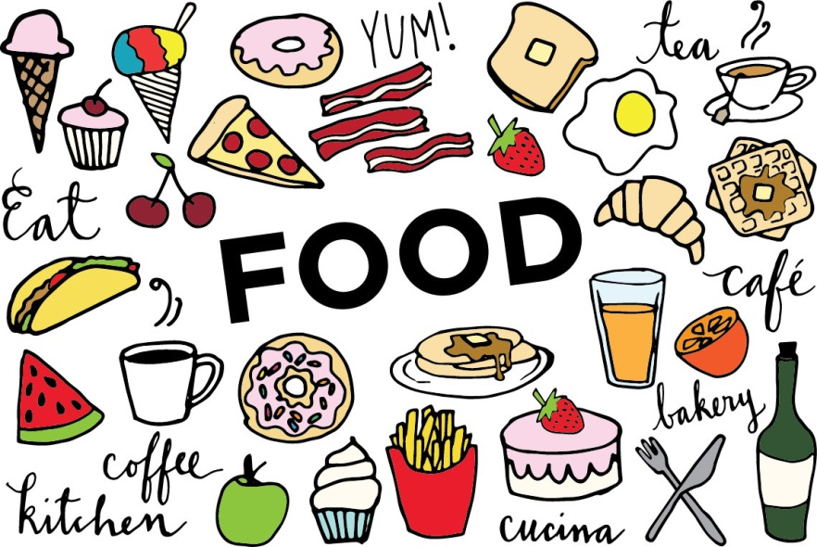

БРЯНСК 2016

Рекомендована методическим Советом ФГБОУ СПО «БГУОР»
Протокол методического Совета № ___ от «___» ____________ 20____ г.

Разработчик:
Сёмина К.С. – преподаватель иностранного языка

Материалы методической разработки адресованы студентам колледжей, училищ, а также учащимся школ и всем, кто заинтересован в изучении английского языка.
Цель пособия – развитие навыков устной и письменной речи по теме «Еда и напитки».
В пособии отражены основные лексические единицы, а так де диалогические ситуации, необходимые при понимании и общении. С помощью данного пособия студенты могут научиться понимать меню за рубежом, читать и понимать рецепты на английском языке, общаться с официантами, делать заказы.

Список литературы:

1. Дроздова Т.Ю. Everyday English: учебное пособие. – 7-е изд. – СПб.: Антолгия, 2009 – 592 с.

2. Clive Oxenden New English File. Beginner Student's Book. - Oxford University Press, 2009 - 120 с.

3. Clive Oxenden New English File. Elementary Student's Book. - Oxford University Press, 2009 - 160 с.

4. Голицынский Ю.Б. Spoken English Пособие по разговорной речи. – СПб.: КАРО, 2012 – 416 с.

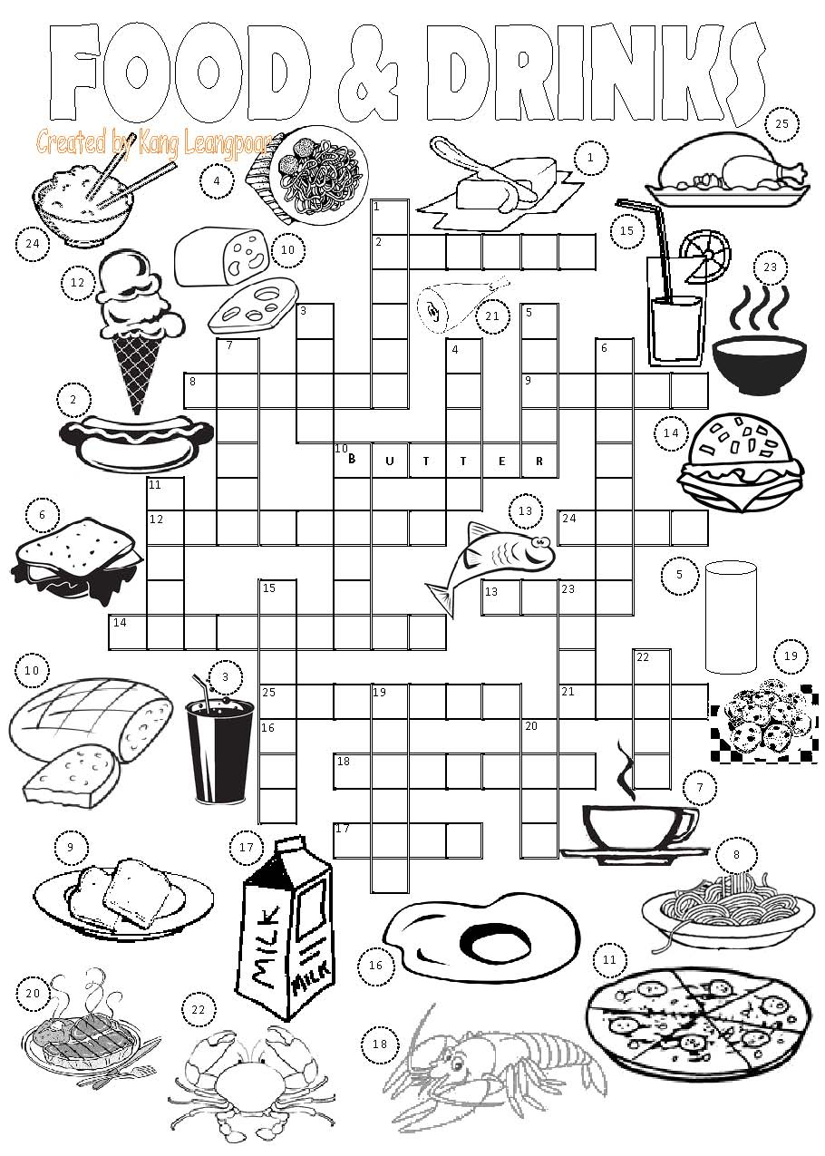

CОДЕРЖАНИЕ:

I. Лексический минимум по теме……………………………... | 4
II. Topical texts ……………………….…………………………. | 12
III. Listening. ……………………………………………………. | 19
IV. Dialogues …………………………………………….…….… | 21
V. Activities……………………………………………………… | 26
Список литературы ……………………………...…………… | 31

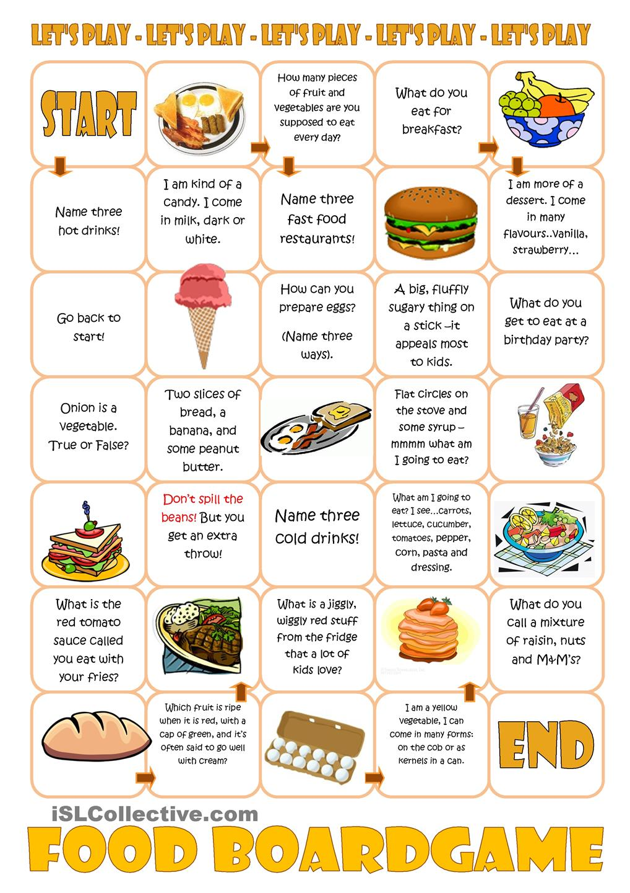
I. ЛЕКСИЧЕСКИЙ МИНИМУМ ПО ТЕМЕ:

FOOD and DRINKS

Meals:
breakfast - завтрак
lunch - ланч/обед, второй завтрак
dinner – обед/ужин
supper – ужин
tea - чай
break for coffee/tea – перерыв, чтобы выпить кофе/чай
have smth. for breakfast/lunch/dinner – иметь что-нибудь на завтрак/обед/ужин
first/second course – первое/второе блюдо
dessert – десерт
to have a meal – принимать пищу, есть
to have breakfast/dinner/supper – завтракать/обедать/ужинать
to have a bite/to have a snack – перекусить

Preparing food/methods of cooking:
to fry – жарить
to bake – печь
to steam – варить на пару
to roast – жарить
to chop – отбивать
to slice – резать ломтиками
to stir – размешивать
to grate – тереть, измельчать
to peel – снимать корку, кожицу, чистить (овощи, фрукты)
to mince – пропускать через мясорубку
to stew – тушить
to grill – жарить в гриле
to spread – намазывать
to boil – кипятить, варить
to marinate – мариновать
to strain – процеживать
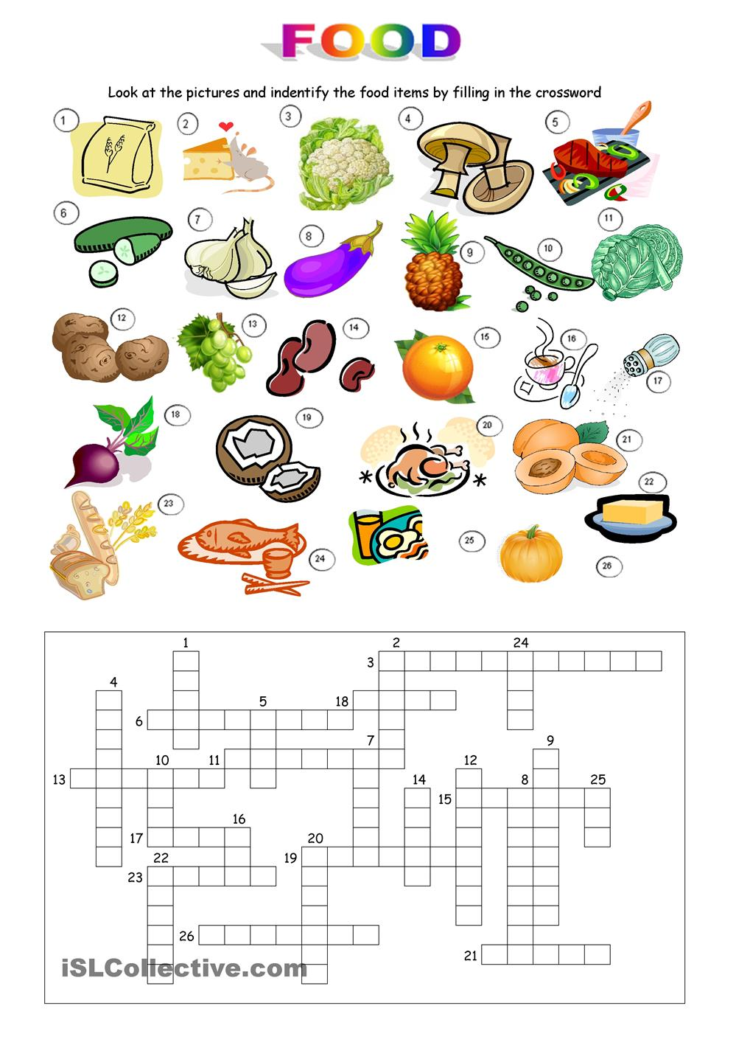

Dairy products:
milk - молоко
butter – сливочное масло
cheese - сыр
processed cheese – плавленый сыр
cream cheese - сливочный сыр
cream – сливки
yoghurt - йогурт
eggs - яйца
cottage cheese – творог
sour cream – сметана
hard-boiled eggs – яйца вкрутую
soft-boiled eggs – яйца всмятку
scrambled eggs – яичница ,jkneym(в которой желток и белок смешаны)
fried eggs – яичница (глазунья)
omelette – омлет

Vegetables:
cabbage – капуста
beans – бобы
beetroot – свекла
carrots – морковь
cauliflower – цветная капуста
cucumber – огурец
garlic – чеснок
onions – лук
peas – горох
potatoes – картофель
tomatoes – томаты, помидоры
fried/ boiled/mashed potatoes – жареный/вареный картофель/пюре

Fruit:
apple – яблоко
apricot – абрикос
banana – банан
lemon – лимон
orange – апельсин
olives – оливки
peach – персик
pear – груша
pineapple – ананас
watermelon – арбуз
tangerine – мандарин
grapes – виноград
grapefruit – грейпфрут
melon – дыня
nut - орех
peanut – арахис
canned fruit -консервированные фрукты

Berries:
blueberry – черника
strawberry – земляника, клубника
gooseberry – крыжовник
raspberry – малина
cranberry – клюква
black/red currant – черная/красная смородина
cherry – вишня
plump – слива
Fish:
cod – треска
plaice – камбала
salmon – лосось
trout – форель
caviar - икра
herring – сельдь
perch - окунь
pike –щука
bream - лещ
carp - карп

Догадайтесь значение английских слов и распределите по колонкам: «фрукты» и «овощи»

Apple potato cucumber banana grapefruit carrot apricot grapes tomato pepper cabbage watermelon plum lemon lime mushroom cauliflower onion radish mango melon оrange peach avocado asparagus olive Garlic raspberry red currant strawberry pear pumpkin

Fruits | Vegetables

Food idioms
Gap-Fill Exercise
bacon beans cake cakes cheese egg pancake pickle pie tea

- If something is very easy, it's a piece of____________.
- If someone is full of energy, we say they are full of____________.
- If you are in a difficult situation, you are in a _________________.
- If you are embarrassed, you have ______________on your face.
- If two people are very different, they are like chalk and___________.
- Something that is very flat is as flat as a ___________________.
- Something which isn't suitable for me isn't my cup of____________.
- Something which sells very quickly sells like hot _____________.
- Something which is impossible or imaginary is ______________in the sky.
- If you rescue someone from a difficult situation, you save their ________.

V. ACTIVITIES:

F | O | O | D | A | C | D | M | F | K | Q | C | M | B
V | X | R | T | M | E | O | P | R | U | I | P | B | R
E | G | U | W | T | A | X | B | V | X | T | A | L | E
G | A | S | L | N | T | Z | T | F | I | S | H | D | A
E | M | B | W | A | S | U | W | Y | T | S | O | R | D
T | E | C | I | N | E | S | W | E | H | N | U | T | S
A | B | L | E | S | S | Z | E | E | G | R | J | K | H
D | C | E | R | F | V | Q | Y | T | S | P | I | C | L
G | E | I | E | A | L | S | F | S | O | U | I | E | S

B
R
I
T
I
S
H
M
E
A
L
S

Seafood:

prawns – креветки
mussels – мидии
shrimps – креветки
octopus – осьминог

Meat:
bacon – бекон, копченая свиная грудинка
beef – говядина
lamb – мясо молодого барашка
mutton - баранина
mince (mincemeat/minced meat) – фарш
pork – свинина
sausages – колбасы
smoked sausage – копченая колбаса
veal – телятина
ham – ветчина
chops (cutlets) – котлеты
beefsteak – бифштекс
meat balls - фрикадельки
liver – печень
kidneys – почки
tongue – язык
Poultry:
chicken – цыпленок
duck – утка
goose – гусь
turkey – индейка

Cereal products and baking ingredients:
barley – ячмень
buckwheat – гречневая каша
oatmeal porridge – овсяная каша
flour – мука
oats – овес
rice – рис
semolina – манная крупа
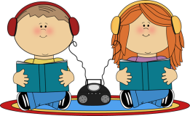
sugar – сахар
oil – подсолнечное масло
yeast – дрожжи
cinnamon - корица
raisin - изюм

Bread:
white bread – белый хлеб
brown bread – черный хлеб
rye bread – ржаной хлеб
stale/fresh bread – черствый/свежий хлеб
roll/bun – булочка
toast – тост (поджаренный кусок хлеба)
croissant – круассан

Soups:
cabbage soup – щи
beetroot soup – борщ
pea soup – гороховый суп
fish soup – рыбный суп
stick soup – суп-пюре
chicken broth – куриный бульон
noodle soup – лапша
Beverages:
fruit juice – фруктовый сок
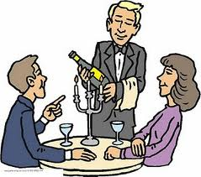
mineral water – минеральная вода
wine – вино
beer – пиво
soft drinks – безалкогольные напитки
coffee – кофе
tea – чай
soda water – газированная вода
cocoa – какао
hot chocolate – горячий шоколад
cocktail – коктейль
stewed fruit (compote) – компот

Allie and Mark are having dinner. Complete the ‘you hear’ phrases.

YOU HEAR | YOU SAY
Good ________ .  Do you have a reservation?  __________ or non-smoking?  Come this ______, please?  Are you _______ to order?  What would you like to____?  Thank you, sir. | A: Yes, a table for two. My name is Allie Gray.  A: Non-smoking, please.  M: Yes, I’d like the onion soup and then the steak, please.  A: The goat’s cheese salad and the lasagna for me, please.  M: Would you like some wine?  A: No, thanks. Just mineral water, please.  M: OK. A glass of red wine and a bottle of mineral water, please.  M: Thank you

Listen and answer the question.
What would they order for dessert/for coffee?

Listen and answer the questions.

- What do Mark and Allie get?
- How much is it?
YOU HEAR | YOU SAY
Can I help you?  ¹_________ or large?  To have here or ² _______?  ³_________ else?  OK.  Together or ⁴_______?  That’s ⁵_______, please.  ___________. Thank you. | M: What would you like?  A: A cappuccino, please.  A: Large, please.  M: And can I have an espresso, please?  M: To have here.  A: No, thanks.  M: A brownie for me, please.  M: How much is that?  M: Together.  M: Sorry, how much?

Listen to Mark and Allie. Circle the correct answer.
There is/isn’t a free table.
Mark/Allie spills the coffee.
Their next meeting is at 11.15/12.30
Allie agrees/doesn’t agree to go shopping for a new shirt.

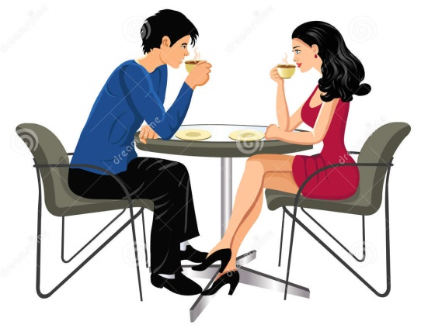

Greens and Dressings:
dill – укроп
spring onion – зеленый лук
parsley – петрушка
lettuce – салат
horse –radish – хрен
ketchup – кетчуп
mayonnaise – майонез
mustard – горчица
pepper – перец
salt – соль
sauce – соус
spices – пряности
vinegar – уксус
Sweets and Pastry:
cake – торт, кекс
pie – пирог
ice cream – мороженое
biscuits – печенье (сухое)
cookies – печенье (сдобное)
cracker – крекер
marmalade –конфитюр, повидло, мармелад
honey – мед
jam – джем, варенье
gingerbread – имбирный пряник
wafer – вафля
chocolate – шоколад
candy/sweet – конфета
sandwich -сэндвич, бутерброд
pancake -блины
jelly -желе
tart – сладкий пирог
pudding - пудинг

Attributes:
tasty – вкусный
tasteless – безвкусный
bitter – горький
sour – кислый
undersalted – недосоленый
oversalted – пересоленый
crispy – хрустящий
spicy – острый
a bit overdone – немного недожаренный
a bit underdone – немного пережаренный
delicious – вкусный
well roasted – хорошо прожаренный
badly stewed – плохо тушеный
very hot – очень горячий
cold – холодный
sweet – сладкий
raw – сырой
smoked – копченый
canned – консервированный
cheap – дешевый
expensive – дорогой
marinated –маринованный

Quantities of food:
a bar of chocolate – плитка шоколада
a bottle of lemonade – бутылка лимонада
a bowl of soup – тарелка супа
a box of sweets – коробка конфет
a carton of milk – пакет молока (сделанный из картона)
a clove of garlic – зубчик чеснока
a jar of jam – баночка варенья
a loaf of bread – буханка хлеба
a lump of sugar – кусок сахара
a packet of crisps – пакет чипсов
a pinch of salt – щепотка соли
.Разыграйте диалог, переведя русские предложения на английский язык.
(В ресторане)
- Вы не проголодались?
- Oh, yes I am.
- А я очень хочу пить.
- Would you like a glass of orange juice?
- Спасибо. С удовольствием. Мне очень нравится апельсиновый сок.
- And I prefer apple juice.
- Все соки полезны для здоровья: томатный, яблочный, абрикосовый и, конечно, ананасовый.
- I like pine apple best of all.
- Что мы возьмем?
- The three course dinner, I suppose.
- Что же, выбирайте.
- Let’s start with salad, then chicken soup, fish and chips.
- Я думаю, я возьму зеленый горошек, фрукты и чашку чая без сахара.
- Are you slimming?
- Да.
- What does your diet allow you?
- Немного мяса или рыбы, яйца, немного сыра или молока и много овощей: зеленый салат, капуста, помидоры, огурцы, свекла и много фруктов. Никаких пирожных, мороженого, шоколада и очень мало соли. Я живу не для того, чтобы есть, а ем для того, чтобы жить.
- Да, вкусы бывают разные.

2. At the Restaurant
A: Shall we have our dinner in this restaurant? They serve very good meals here and the prices are reasonable.
B: Well, you lead. You should know better. (In the restaurant)
A: What shall we have? A three-course dinner, I suppose. I’m awfully hungry.
B: So am I. And I’m thirsty too.
A: Then let’s have a glass of mineral water first or some orange juice.
B: I’d prefer orange juice with ice or iced tea.
A: Waiter! Iced orange juice and a glass of mineral water, please. Now, let’s see the menu and here is the wine list too. Would you like any starters?
B: A salad would do, I think.
A: And I’ll have shrimps. Would you like any soup? As for me I’ll have mushroom soup and smoked salmon for the main course.
B: I like your choice. I’d rather have the same.

3. At the Fast Food restaurant

Waiter: Can I help you?
Customer: Yes, I’d like a hamburger.
Waiter: How would you like your hamburger cooked?
Customer: Well-done.
Waiter: What would you like to drink?
Customer: I’d like a coke, please.
Waiter: What size would you like?
Customer: Medium.
Waiter: Would you like anything else?
Customer: What kind of desert do you have?
Waiter: Today we have chocolate ice cream. How would you like to pay? Cash or credit card?
Customer: by credit card.
Waiter: 5 $ please
Customer: Here you are.

a pint of beer – пинта пива (0, 57 л)
a rasher of bacon – ломтик грудинки
a slice of ham – кусок ветчины

Dishes:
plate – тарелка
glass – стакан
cup – чашка
saucer – блюдце
tea-pot – чайник для заваривания чая
kettle – чайник
fork – вилка
spoon – ложка
knife – нож
tea/coffee set – чайный/кофейный сервиз
dinner set – обеденный сервиз
china set – фарфоровая посуда
sugar basin – сахарница
tray – поднос
mug – кружка
sauce boat – соусница
salt celler – солонка
mustard pot – горчичница
pepper box – перечница
napkin – салфетка
table cloth – скатерть
table mat – столовая клеенка
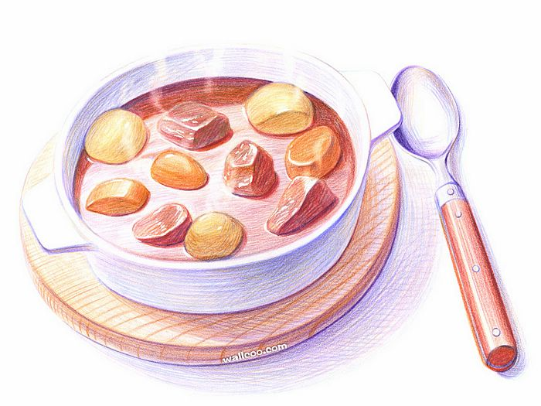
dish towel – полотенце для посуды

II. TOPICAL TEXTS
Read and retell the text.
BRITISH MEALS
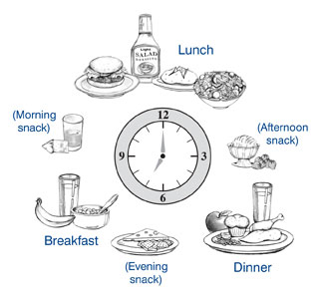
Understanding British meals is, one of the great mysteries to foreign visitors. Over the centuries, the British have shown a tendency to name and rename their meals and to move them about the day in an apparently random fashion. Further to confuse outsiders, the British give different names to each meal depending on social class and part of the country people live in.
Breakfast, which was once taken at 5 o'clock in the morning, can now be at any time before 11.30. It has thus overtaken dinner. In Norman times — in the 12th century -— dinner was at 9 a.m.; by the 15th century, it had moved to 11 a.m.; and today it can be eaten at any between noon and 2.30 in the afternoon and is called lunch by a large proportion of the population, especially the middle and upper classes and people from southern Britain. Many farm labours, however, who start work at sunrise and have their breakfast before they "go to work, still stop for a lunch break at about 9 o'clock.
In the 14th century, supper was at 4 o'clock — which is now called tea-time. But outside the south-east of England, working families have tea or high tea at about 6 in the evening while the rest of their fellow countrymen have dinner, which is often called supper, at about 7.30p.m.

IV. DIALOGUES:

1. Lunch for Two
Mr. Smith: Hello. Do you have a table for two, please?
Head waiter: Good evening, sir. Sure. This way, gentlemen. Here is the menu.
Mr. Smith: Now, let’s see. What shall we have to start off with? The prawn cocktail’s very good or the melon is not bad at this time of year.
John: Yes, sir. I think I’ll have the prawn cocktail.
Mr. Smith: OK. And what shall we have to follow?
John: You know what I’d like something typically American.
Mr. Smith: OK then. How about the roast beef?
John: All right. I’ll try that.
Mr. Smith: That’s settled then. We’ll have prawn cocktails to begin with and roast beef to follow.
Head waiter: Very good. What vegetables would you like?
Mr. Smith: Oh, French fries and asparagus, I think. What about you, John?
John: Is that what one usually eats with roast beef?
Mr. Smith: Yes.
John: I see. Well, I’ll have asparagus but I don’t think I’ll bother with the potatoes.
………………………………
Waiter: Any coffee, sir?
Mr. Smith: No, thanks, actually. We are in a bit of a hurry. Could we have the bill straight away, please?
Waiter: Sure. I’ll bring it immediately.
John: Look, Mr. Smith. Let me do this.
Mr. Smith: No, no. This one is on me. You can pay next time. Here you are,waiter…
John: Well, that’s very kind…

PEOPLE IN THE STREET

1. Where do you usually have lunch?
2 What do you have?
3 How much is it?

Listen to Brandy. Where does she usually have lunch? What does she have?
How much is it?
Listen to four more people

Read and translate the text. Write out the words on the topic Food, meals and drinks.

TAKING MEALS IN BRITAIN AND TRADITIONAL BRITISH FOOD

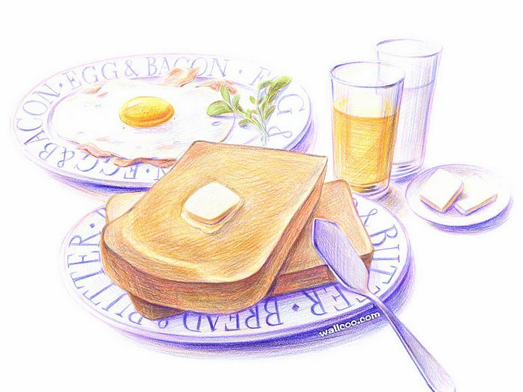
Every country has its own eating habits.
The legendary English breakfast is a hearty meal and the perfect start to a hard working day. Visitors to Britain often think that breakfast is the best meal of the day. This favourite meal consists of bacon, eggs, tomato, fried bread and a variety of sausages. It is usually finished off with slices of toast spread with orange marmalade and a cup of tea, with milk or lemon. But today many people eat a healthier food, they start their day with muesli, yoghurt and fruit juice. Such a breakfast is healthier because muesli and fruit juice contain less fat.
At lunch-time lots of people find it impossible to get home to eat something so they go to a cafe or restaurant. Lunch consists on weekdays, for example, of fried fish, chops, liver, or sausages, and some kind of vegetables, usually carrots, cabbage, cauliflower or peas, and potatoes; rice and macaroni are seldom served.
The sweet sometimes called dessert, may consist of fruit or the famous pudding and fine British cheeses with biscuits. Those who are at home generally take cold meat with salad, fish or roast meat and vegetables. Then they have sweets, biscuits or cold fruit salad.
Afternoon tea (which is usually taken at 4 or 5 p.m.) is when the British love for cakes and for tea-drinking come together. It is a very light and the most informal meal of the day. If you are a friend of the family you may drop in for tea without an invitation.
Dinner is usually at 7 o'clock. It is the most substantial meal of the day and is a very formal one. Many people even wear special clothes for dinner. Sunday dinner is a special occasion. The English occasionally like to drink water or beer with their meal, but it is only in the expensive restaurants or among upper class people that spirits are taken with the meal. Spirits are generally too expensive for the normal household, except at Christmas time.
It must not be imagined that all English people eat like this. Not 10% of them do so. In a great many English homes the midday meal is the chief one of the day while in the evening they have a much simpler supper — an omelette, or sausages, sometimes bacon and eggs, or whatever they can afford.
Read and translate the text. Answer the questions.
AMERICAN FOOD
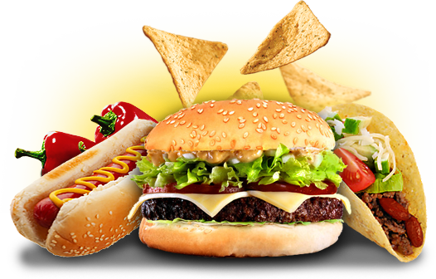
Americans have a wider assortment of foods to choose from than consumers in any other country. Meats, fish, fruits, vegetables, nuts, cereals from various parts of the nation are available throughout the country during any season of the year. Frequently, the problem for the consumer is not the lack of variety of brands of food, but rather the bewildering Assortment from which one must choose. In addition, the consumer can choose from foods that are fresh, frozen, canned and cooked or uncooked, currently, virtually all food stores have available a wide" array of frozen foods especially prepared to be heated or cooked in a microwave oven.
The microwave oven has revolutionized the home preparation of meals. It, along with the supermarket, where virtually any kind of foods, are available, make the preparation of food the most time-efficient in the world. A family can make only one trip a week to the supermarket to purchase its food needs for an entire week. Before the

III. LISTENING.

Listen to the programme ‘Can Men Cook?’
What nine things does Colin use to make spaghetti bolognese?

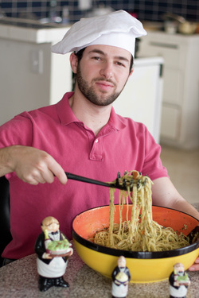
1. some ______________________
2. an ________________________
3. some ______________________
4. a _________________________
5. some______________________
6. some_______________________
7. some_______________________
8. some_______________________
9. some_______________________

Listen again and read the dialogue. Write the missing words.
What does the woman ask for? How much is it?

Barman Can I help you?
Woman Yes, can I have a 1_____ and a chocolate brownie, please?
Barman Espresso Americano,Сappuccino?
Woman An espresso2______.
Barman Single or 3 _________?
Woman Single. 4_______ much is that?
Barman Two pounds forty-five.
Woman 5_______ you are.
Barman Thanks.

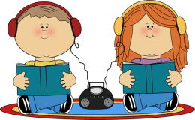
Listen to William, who is English, on an American radio programme called “You are what you eat”. What's his favourite meal?
Listen and tick () the things he has:

Breakfast:
bread butter croissant cereal tea coffee
Breakfast at the weekend:
eggs bacon vegetables sausages
Lunch:
a sandwich a pizza a hamburger water beer juice
Dinner:
meat rice pasta fish salad vegetables potatoes


In your country...
What do people have for breakfast?
Do people prefer tea or coffee?
Do they have a big meal for lunch or for dinner?
Do they eat a lot of fruit and vegetables?
Do they eat a lot of fast food?
In your family...
What do you have for breakfast at the weekend?
What do you usually drink with lunch and dinner?
Do you eat a lot of rice?
Do you eat a lot of pasta?
Do you eat a lot of potatoes?
Do you eat a lot of meat?
Do you eat a lot of fish?
Do you have dinner together?
Do you watch watch TV or talk?
turn of the century Americans will have access to computer-based shopping enabling them to make their buying decisions at home and picking up their purchases at the store or having them delivered to their homes.
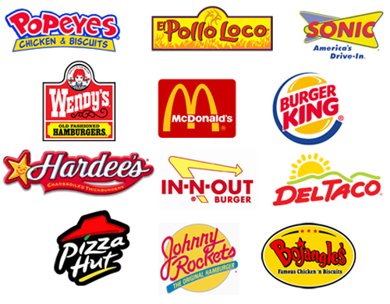
Since the 1950s fast-food and take-out restaurants have had a phenomenal proliferation, first in the US, and more recently throughout the world. The/'first fast- food chains like McDonalds, Burger King, Arby's and Wendy's which offer sandwiches, hamburgers, French-fried potatoes, hot dogs, pizzas, pancakes, chili and fried chicken, have been joined by other chains some of which offer Mexican, Chinese and other ethnic foods. The cost of the food in such restaurants is frequently cheaper than if one were to prepare similar food in one's kitchen. Consequently, an entire family may frequently go to eat at fast food places for convenience and economy.
A more recent development in the American food industry has been the demand for healthier foods. The food industry has made available a wide variety of low-fat dairy and meat products. Animals are now being scientifically bred to produce lean meat. Even low fat cheeses and ice creams are being produced. Vegetable, fruit and cereal consumption are increasing. A second demand is for foods grown and produced free of fertilizers, pesticides and herbicides. This has led to the development of an "organic food" industry. Of course, the cost of organic foods is substantially higher than for nonorganic food. The market for organic food has nevertheless been expanding.
(from "Life and Issues in the USA ")

Comprehension questions:
- What problem do American consumers face when buying food?
- How often does a family visit a supermarket to purchase its food for a week?
- What will enable Americans to make their buying decision right at home?
- What is the secret of success of fast-food and take-out restaurants?
- What is a more recent development in the American food industry?
- Which food items are very popular now in America?

Fill in the appropriate words from the right column.
If you …………….. there are certain……………. you really have to avoid: ……………..and…………… are out for a start, but you can’t live forever on…………….and …………….There are men and women who spend their entire lives counting…………..they take in each day. Some national…………….make you fat. The Japanese have a high protein diet, while the Swiss eat a lot of……………. Personally, I’m lucky not to have to diet, but my friend, John, can’t eat anything without looking it up in his Calorie Chart. This is carefully organized so that…………….and……………...are under “Fruit”; ……………..and…………………come under “Starchy Foods”, and so on. I entertained John to a nice low calorie……………yesterday and at the end I offered him some……………….”What does “jelly” come under?” he asked looking at this chart. “Half a litre of double cream”, I said, pouring the stuff over my plate! | Meal  biscuits  tomatoes  jelly  cuisines strawberries spaghetti  foods  are dieting  the calories potato  cakes  oranges  milk products peaches  diet

Put each of the following words or phrases in its correct place in the passage.
vegetarian | washing up | crockery | starter
side | dish | dessert | diet
cutlery | main course | entertaining | napkin
sink
Maureen often gives dinner parties at home. She loves (a)……. She lays the table: puts the (b)…… in the right places, sets out the plates and puts a clean white (c)…… at each place. For the meal itself, she usually gives her guests some kind of (d)…… first, for example soup or melon. Next comes the (e)…… is usually meat (unless some of her guests are (f)…… or if they’re on a special (g)…… with a (h)……of salad. For (i)…… it’s usually fruit or ice-cream, and then coffee. When everyone has gone home, she must think about doing the (j)…… , as in the kitchen the (k)…… is full of dirty (l)…… .

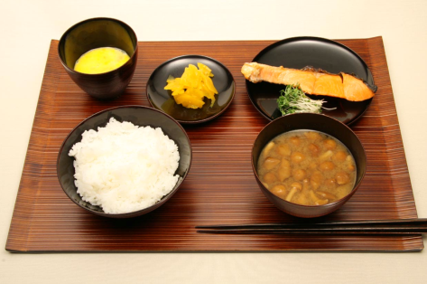
Ken from Osaka in Japan
In my family we have a traditional Japanese breakfast. It isn't very different from lunch and dinner. We have rice, fish, and miso soup, and we drink green tea. Today a lot of Japanese people have a European breakfast. They have bread and croissant and they drink coffee, not tea. But I prefer our breakfast. In my family we don't talk at breakfast. We eat drink and watch TV!
Katalin from Nikla in Hungary
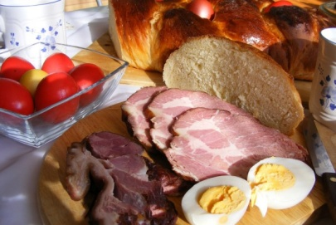
In Hungary breakfast is an important meal. In my family we have eggs, cheese, cold meat, sausage, and bread. We drink tea or coffee, and fruit juice. Some men have a small 'pálinka' at breakfast time - it's a traditional Hungarian brandy. It's very strong, and I don't like it, especially not for breakfast!
Read the texts. Then read sentences 1-5 and mark the sentences T (true) or F (false).
1. In Japan people eat very different things for breakfast, lunch, and dinner.
2. Ken's family like croissants for breakfast.
3 In Japan a lot of people don’t have a traditional breakfast.
4 In Hungary people eat a lot for breakfast.
5 Some Hungarian men drink alcohol with breakfast.

