Федеральное государственное бюджетное учреждение
профессиональная образовательная организация
«Брянское государственное училище (колледж) олимпийского резерва»

КОМИССИЯ ДИСЦИПЛИН
СОЦИАЛЬНО-ГУМАНИТАРНОГО ЦИКЛА

Family

МЕТОДИЧЕСКАЯ РАЗРАБОТКА ПО АНГЛИЙСКОМУ ЯЗЫКУ

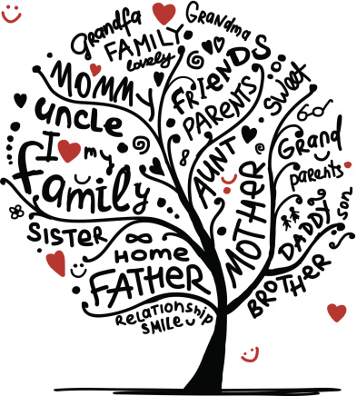

БРЯНСК 2016

Рекомендована методическим Советом ФГБОУ СПО «БГУОР»
Протокол методического Совета № ___ от «___» ____________ 20____ г.

Разработчик:
Сёмина К.С. – преподаватель иностранного языка

Материалы методической разработки адресованы студентам колледжей, училищ, а также учащимся школ и всем, кто заинтересован в изучении английского языка.

Настоящее учебное пособие имеет целью помочь студентам выработать навыки устной и письменной речи на основе тематически подобранных текстов, которые расширяют возможность работы над темой «Семья».
Пособие состоит из разделов, включающих тематические тексты, лексику,
подлежащую активному усвоению, и упражнения, способствующие развитию навыков монологической и диалогической речи.
Данное пособие может быть использовано как в аудитории для выполнения заданий под руководством преподавателя, так и для самостоятельной работы студентов.

CОДЕРЖАНИЕ:

I. Topical vocabulary. Лексический минимум по теме……………………………... | 4
Text 1. Family……………………….………………………………………...………. | 6
Text 2. About myself and my family ……………………………………………………. | 8
II. Lexical exercises. …………………………………………………….….…….… | 10
III. Activities……………………………………….………………………………… | 16
IV. Test yourself! ……………………………...…………………………………….. | 22
Список литературы ……………………………...…………………………………. | 26

I. TOPICAL VOCABULARY.

Name (first name; Christian name)  Patronymic  Middle name  Surname (last name, family name)  Namesake  Maiden name  Nickname  Pet name  Pen name  To call  To call by first name  To call smb after  Be born  Birthday  Nameday  Be sixteen years old  Be a sixteen- year-old-boy  Nearly sixteen  About twenty  Under eighteen  Over twenty  Teenager  Be of age (under age)  To age (fast/slow)  Middle aged person  An elderly person  As old as the hills  Be of the same age  Five years older/younger than  No older than  Double/twice one’s age  Look one’s age  Look older than  Die  Birthplace  Countryman/countrywoman  Husband  Wife  Mother (mum, mommy/mummy)  Father (dad, daddy)  Daughter  Son  Uncle  Aunt  Niece  Nephew  Sister  Brother  Elder brother/ sister  Younger brother/ sister  Godfather  Godmother  Ancestry  Grandchildren  Granddaughter  Grandson  Cousin  Distant cousin  Children  Child  Baby  Kid  Toddler  Twins  Fostermother  Fosterfather  Stepmother  Stepfather  Grandparents  Grandmother (granny, grandma)  Grandfather (granddad, grandpa)  Mother-in-law  Father-in-law  Brother-in-law  Sister-in-law  Daughter-in-law  son-in-law  adopt  raise (bring up)  widow  widower  bachelor  orphan  give birth to  distant relatives  relative  parents  engagement  wedding  marry somebody  marriage  bride  bridegroom  mate/spouse  divorce | Имя  Отчество  Фамилия  Тёзка  Девичья фамилия  Прозвище  Ласкательное имя  Псевдоним  Называть  Называть по имени  Называть вчесть  Родиться  День рождения  Именины  Шестнадцать (быть шестнадцатилетним)  Шестнадцатилетний юноша  Почти 16  Около 20  Меньше 18 (еще нет 18)  Больше 20  Подросток  Достичь совершеннолетия (не достичь совершеннолетия)  Стареть (быстро/медленно)  Человек средних лет  Пожилой человек  Старый как мир  Быть одного возраста  На 5 лет старше/младше, чем  Не старше, чем  В два раза старше  Выглядеть на свой возраст  Выглядеть старше, чем  Умереть  Место рождения  Соотечественник/соотечественница  Муж  Жена  Мать  Отец  Дочь  Сын  Дядя  Тетя  Племянница  Племянник  Сестра  Брат  Старший (ая) брат/сестра  Младший (ая) брат/сестра  Крестный отец  Крестная мать  Предки  Внуки  Внучка  Внук  Кузен, кузина (=двоюродный брат/сестра)  Троюродный (ая) брат/сестра  Дети  Ребенок  Малыш (младенец)  Малыш (старше baby)  Ребенок (1-3 года)  Близнецы  Приемная мать  Приемный отец  Мачеха  Отчим  Бабушки и дедушки  Бабушка  Дедушка  Свекровь (=мать мужа), теща (=мать жены)  Свёкор (=отец мужа), тесть (=отец жены)  Зять (=муж сестры)  Невестка/золовка (=жена брата)  Невестка (=жена сына)  Зять (=муж дочери)  Удочерять, усыновлять  Воспитывать (детей)  Вдова  Вдовец  Холостяк  Сирота  Родить (ребенка)  Дальние родственники  Родственник  Родители  Помолвка  Свадьба  Жениться на /выходить замуж за  Женитьба, замужество, брак  Невеста  Жених  Супруг/супруга  Разводиться/развод

TEXT 1. FAMILY
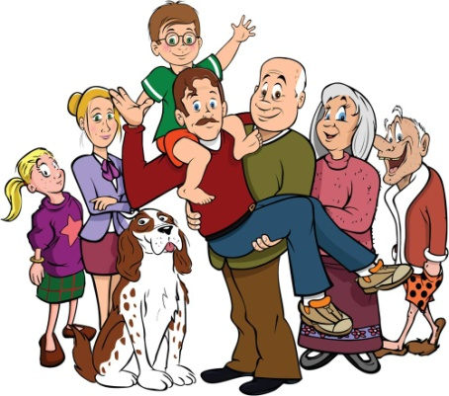
There are many different views on family life. Some people could not do without the support and love of their families.
A “typical” British family used to consist of a mother, a father and two children, but in recent years there have been many changes in family life. Some of these have been caused by new laws and others are the result of changes in society. For example, since the law made it easier to get a divorce, the number of divorces has increased. In fact, one marriage in three now ends in divorce.
This means that there are a lot of one-parent families. Society is now more tolerant than it used to be of unmarried people, unmarried couples and single parents.
Members of a family – grandparents, aunts, uncles, cousins – keep in touch, but they see less of each other than they used to. This is because people often move away from their home town to work, and so their family becomes scattered.
Relationships within the family are different now. Parents treat their children more as equals than they used to, and children have more freedom to make their own decisions. The father is more involved with bringing up children, often because the mother goes out to work.
Although the family holiday is still an important part of family life (usually taken in August, and often abroad) many children have holidays away from their parents.
And what is the American family like? Most American families consist of a mother, a father and three or four children living at home. Their familial structure is known as the “nuclear family”. It is unusual for members of the family other than the husband, wife and children to live together. Occasionally an aging grandparent may live with the family.
In the American family the husband and wife usually share important decision making. When the children are old enough, they participate as well. The father seldom expects his children to obey him without question, and children are often allowed to do what they wish without strict parental control. Independence is highly valued in the United States.
Young people are expected to break from their families by the time they have reached their late teens or early twenties.

Exercise 1. Read the text “Family” carefully for details. Look in the text for the answers.
1) Describe a “typical” British family.
2) Have there been many changes in British family life in recent years? What are the causes?
3) Marriage and the family are not so popular now, are they?
4) Why do members of a family – grandparents, aunts, uncles, cousins – see less of each other than they used to?
5) And what is the American family like?
6) Who usually shares important decision making in the American family?
7) Is independence highly valued in the United States?
8) At what age are young people expected to break from their families?

Exercise 2. What do we call these people? (Use Topical Vocabulary)
1) your mother’s father;
2) your father’s sister;
3) your father’s brother’s son;
4) your sister’s daughter;
5) your mother’s second husband (who is not your father);
6) your father’s grandmother;
7) your son’s wife;
8) your daughter’s husband;
9) your daughter’s daughter;
10) your sister’s husband;

Exercise 3. Read the text. Translate it paying special attention to the underlined words and word-combinations. Do it in writing.

The Unhappy Man
A London newspaper recently published a case of suicide, in which the reasons that moved the unhappy man to lay violent hands upon himself were found in the shape of a letter in his left boot. In this letter he wrote:

“I married a widow who had a grown-up daughter. My father visited us frequently, fell in love with my step-daughter and married her. Thus my own father became my son-in-law, and my step-daughter, being the wife of my father, became my mother. After some time my wife presented me with a son, - of course, he was my father’s brother-in-law and my uncle, for he was the brother of my step-mother.
My father’s wife, that is my step-daughter, had also a son, - of course, he was my brother, but at the same time he was also my grandson, for he was the son of my daughter. My wife was also my grandmother, being the mother of my mother.
I was the husband of my wife, but at the same time also her grandson, and since the husband of my grandmother is naturally also my grandfather, I am my own grandfather. ... I should like to see the man who could bear all this.”

Exercise 4. Read the following sentences, say if they are true or false.
1) Mr Green is single, his wife’s name is Helen.
2) My nephew is a very nice girl. She is the baby of the family.
3) Peter lives with his parents, he has no family of his own.
4) Mary has a younger sister. They are twins.
5) They got married. They are husband and wife.
6) Bob and Jane are a newly married couple. His parents are her grandparents now.
7) Jack’s sister has three children: two sons and a daughter, they are Jack’s cousins.

Exercise 5. Put each of the following words in its correct place in the passage below.
Widow, stepchildren, fiancé, brother, widower, name, younger, close, spinster, get married, cousins, bachelor, stepmother, distant.

My ... is Tom Smiles. I’m the eldest of all the children. My second ... is Jack. The youngest is Michael. My ... sister is two years younger than me. Some time ago she got engaged. Her ... is Mr. Brown. They are going to ... next month.
I have many relatives. My grandparents are dead. But I have a number of ... and relatives: two uncles, four aunts and about a dozen cousins. One of my ... has lost her husband. She is a ... . An uncle of mine has been a ... for many years, but he married recently. His wife is very kind to his ... and treats them as a real mother would do. They love and respect their ... .
My second aunt has remained unmarried and therefore she is what the English call a ... or a single lady. An uncle of mine has also remained single. He is an old ... .

TEXT 2. ABOUT MYSELF AND MY FAMILY
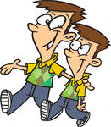
Let me introduce myself to you. I am John Brown, an Englishman. I am twenty-five years old. By profession I am a doctor. I work at a large hospital in London. I am unmarried.
Our family is large. We are six: my father, my mother, my grandmother, my brother, my sister and me. We all live together. My parents are not old. My father, George Brown, is fifty-five; and my mother, Jane Brown, is fifty-two. My father is a manager of a big plant. My mother does not work, she is a housewife. My grandmother, Katherine Smith, is a pensioner. She helps my mother to keep house.
My brother’s name is Michael. He is a young scientist. We are twins. Mary, our sister, is five years younger than we are. She is twenty and she studies at the University of London at the Faculty of Arts. She is a third-year student.
My sister is unmarried. My brother Michael is going to marry this summer. His bride, a nice young woman, is a musician. Her name is Elizabeth. As to me, I am a typical bachelor.
We live in a two-storeyed cottage in the suburb of London.

Words and expressions:
to introduce smb. to smb. [ɪntrəˈdjuːs] – представить кого-либо кому-либо
to be (un)married [ˈʌnˈmærɪd] – быть (не)замужней, быть (не)женатым
We are six. – Нас (в семье) шестеро.
to keep house [kiːp haʊs] – вести хозяйство
a scientist [ˈsaɪəntɪst] – ученый
twins [twɪnz] – близнецы
a Faculty of Arts [ˈfækəltɪ ɔv ɑːts] – факультет гуманитарных наук
a third-year student [θɜːd jɜː ˈstjuːdənt] – студент(ка) третьего курса
to be going to [ˈgəʊɪŋ tuː] – собираться (что-либо делать)
a bride [braɪd] – невеста
a musician [mjuːˈzɪʃn] – музыкант
as to me [æz tuː mi:] – что касается меня
a typical bachelor [ˈtɪpɪkəl ˈbæʧələ] – типичный холостяк
two-storeyed [-ˈstɔːrɪd] – двухэтажный
a suburb [ˈsʌbɜːb] – пригород
Katherine [ˈkæθrɪn] - Катрин
Michael [maɪkl] - Майкл
Elizabeth [ɪˈlɪzəbəθ] - Элизабет

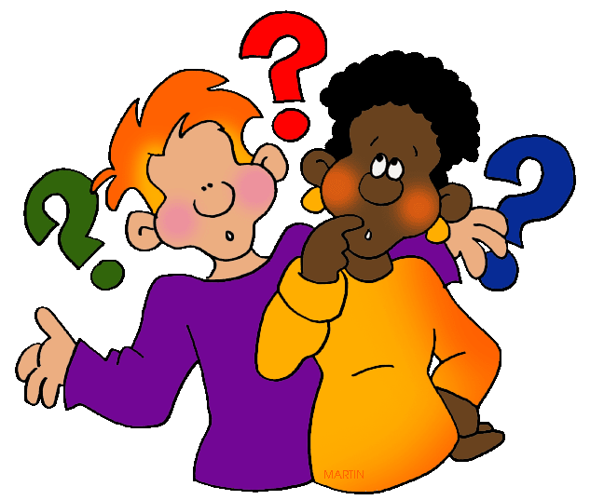
Exercise 6. Answer the questions to the text:

- Is the Browns family large or small? How many are they?
- How old is the father?
- How old are the twins?
- Who is the housewife?
- What is George Brown?
- What is the grandmother’s name?
- How old is Mary? Is she married?
- Who is going to marry?
- Who is a musician?

TEXT 3. FAMILY LIFE.
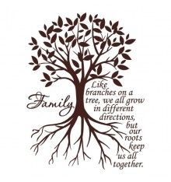
John Parker is about forty, rather tall and well-built. His hair is light brown, he has a healthy complexion, and when you look at him you are met with a very kind expression. He is an English teacher at the local comprehensive school. He has a couple of close friends and a lot of acquaintances. He plays tennis and golf every weekend, he likes reading detective and adventure stories.
John has a wife and two teenage sons. His wife’s name is Lynn. She is slightly younger than he and quite attractive. Lynn is a housewife. She spends a lot of her day time doing tasks about the house: the ironing and the washing, polishing the floor, watering the flowers, cooking and shopping. She is very proud of her wonderful collection of potted plants.
John and Lynn’s sons are both at school. They are twins and so alike that people find it difficult to distinct one from the other. They are very noisy, as all boys are. They are fond of football, climbing, fighting and playing with their dog, the family pet. No wonder the house is much quieter when they are at school than when they at home. But of course the parents still love their boys very much and hope they will have enough money to send both of them to college.
John’s younger brother is called Mike. He is twenty-five, taller than his elder brother, broad-shouldered, good-looking and always ready to have a good laugh. He graduated from university last year. Mike enjoys reporting and hopes to make a career out of journalism. He is still a bachelor and often stays with his brother’s family at the weekend. He is a very good tennis player.
During the holidays the family likes to go on outings. This usually means going to the theatre, watching a local sporting event or a trip to the seaside.

Exercise 7. Answer the questions:
1). Is John Parker about thirty or forty? 2). Is his hair dark or light brown? 3). What is the usual expression on his face? 4). Is John Parker a teacher or a student? 5). Has John got a lot of friends? 6).What does John like to do? 7). Is John married or single? 8). How does Lynn spend her day? 9). What is she proud of? 10). Are their sons at school or at college? 11). Why aren’t their sons at college yet? 12). Why can’t people distinct one of their sons from the other? 13). There is a dog in the Parker’s house, isn’t there? 14).What is Mike? 15). Mike is very serious, isn’t he? 16).What does Mike hope to do? 17). Is Mike married or single? 18). Is Mike good at tennis or at golf? 19).What do the Parkers usually do during the holidays?

Exercise 8. Find word combinations in the text which have the following meaning.
Отправить учиться в колледж; близкие друзья; отличить одного от другого; гостить у; она гордиться своей коллекцией; на выходные; выбираться куда-нибудь из дома; чуть моложе его; стать профессиональным журналистом; много знакомых; детективные и приключенческие рассказы; учиться в школе; тратит большую часть времени на домашние дела; единая средняя школа; окончить университет; играть в гольф; здоровый цвет лица.

Exercise 9. Agree or disagree to the following statements on the text beginning with:
Yes, just so.
Far from it.
I agree with it.
I don’t agree with it.

a). John Parker is a man of sixty. b). He is an English teacher at one of the London colleges. c). John is keen on golf and tennis. d). Lynn doesn’t work. e). Lynn has got a collection of stamps which she is proud of. f). John and Lynn’s sons are schoolboys. g). The boys are quite active and energetic. h). There is a cat in the Parker’s house. i) The parents want to send their boys to the college. j). Mike, John’s young brother, is very serious. k). Mike hopes to make a career out of painting. l). Mike is still unmarried. m). Mike is good at tennis. n). The Parkers prefer to stay at home at weekends.

II. LEXICAL EXERCISES.


Exercise 10. Answer the questions and make up your story:

1. What is your name? When were you born? Where were you born? Is your family large or small? What are your parents?
2. How old are you? When is your birthday?
3. Have you a sister or brother? Is he/she younger or older than you? You are not an only child of the family, are you?
4. Have a grandfather and a grandmother? Do they live with you? How old are they? Do they work or are they already pensioners?
5. What other relatives have you? Have you got many relatives? Do you have uncles and aunts? Whose brothers and sisters are they? Do they live near you? Have you any nephews or nieces? How old are they?
6. Do you go in for sports? What are you good at? What is your hobby? Have you much spare time? Are you fond of music?

Exercise 11. Say in English:

- У меня хорошие родственники.
- Моя сестра не замужем, но она собирается выйти замуж летом. Ее жених врач, ему 25 лет.
- Нас в семье пять человек. Мы с сестрой близнецы. Наши родители музыканты.
- Моя бабушка пенсионерка, а дедушка – нет.
- Мой двоюродный брат женат. Его жена – преподаватель. В это лето они собираются поехать в Лондон.
- Моя двоюродная сестра – студентка гуманитарного факультета университета.
- Мою племянницу зовут Мария, ей 15 лет. Она очень хорошая девочка.
- Моему племяннику всего три года. Его зовут Александр.
- Наша семья большая, и мы все хорошие друзья.

Exercise 12. Read the meanings of the adjectives and try to understand the difference.

Older (Oldest) – Elder (eldest)
Older: more advanced in years than someone else?
Is your brother older than you?
Oldest: older than the others.
Who is the oldest in your group?
Elder: born earlier (of two in the same family)
My elder brother is taller than me.
Eldest: the oldest or first-born (of a family of brothers and sister; more than two)
The eldest girl coached her two little sisters.

Exercise 13. Choose the right word.

Elder - eldest – older – oldest
- Mr. Black is … than his wife. 2. My … brother is in Brazil. 3. Which is the … of the two sisters? 4. Mr. and Mrs. Brown have five sons. The … son has just married. 5. Mr. and Mrs. Hills have three sons. William is the … and Henry is the youngest. 6. Who is the … in your group? 7. Mr. and Mrs. Smith have two daughters, Mary and Jane. Mary is three years … than Jane. 8. Mr. Green is 95. He is the … friend I have.

Exercise 14. Read the dialogue paying attention to the words and word-combinations:

- Your name is George Scott, isn’t it?
- Yes, it is. I am an electronic engineer. I live and work in New York. And what’s your name?
- My name is Peter Brook. I am an editor. I live and work in San Francisco.
- You are married, aren’t you?
- Oh, yes. I am married and I’ve got two daughters.
- What a coincidence! I’ve got two daughters, too: Helen and Mary. What are your daughters’ names?
- They are Susan and Jane. Susan is ten years old and Jane is eight. They both go to a private school. Do your daughters go to school?
- Not yet. Helen is five years old and Mary is three.
- They are at home, aren’t they?
- Sure. My wife doesn’t work now. She runs the house and looks after the children. Emily is the name of my wife. She is a designer. She adores her trade and dreams of going to her office again. But she can’t for the time being.
- It’s only natural. Nowadays very few women are satisfied with being housewives. My wife whose name is Nancy is a teacher of Russian. She works at a college.
- Do you have any brothers or sisters?
- Unfortunately not. I am the only child in the family. I’ve got a cousin who lives in Chicago. We are on friendly terms.
- I have got a sister. She is much younger than I am. She lives with our parents in Los Angeles. I’ve seen very little of her of late.
- Los Angeles is a beautiful city. My aunt lives there and I visit her from time to time.
- It’s a long time since I went to Los Angeles.
- Too bad!

Words and word-combinations:
an editor [ˈedɪtə] – издатель, редактор
What a coincidence! [wɔt ə kəʊˈɪnsɪdəns] – Какое совпадение!
Private [ˈpraɪvɪt] – частный
to run the house [rʌn ðə haʊs] – вести домашнее хозяйство, управлять домом
to look after [lʊk ˈɑːftə] – присматривать
to adore [əˈdɔː] – обожать
to dream [driːm] – мечтать
for the time being [taɪm ˈbiːɪŋ] (nowadays [ˈnaʊədeɪz])– в настоящее время
to be satisfied with [ˈsætɪsfaɪd] – быть довольным чем-либо
to be on friendly terms [ˈfrendlɪ tɜːmz] – быть в дружеских отношениях
to see very little (much) of smb. of late – видеть кого-л. очень редко (часто) в последнее время
Too bad!– Какая жалость!
a housewife [ˈhaʊswaɪf] – домохозяйка

Exercise 15. Read the following dialogues and act them out.
1
- What is the name of your younger brother?
- John.
- Really? Fantastic, we both have a brother John by name.
- Why? John is such a popular name.
2
- Where were you born?
- In London. But my parents come from Manchester.
- How interesting! I comefrom Manchester too.
- Oh, it’s a small world, isn’t it?
3
- Look Jake, have you got a family of your own?
- Oh, no, I’m not married yet.I live with my parents.
- Is your family large?
- I don’t think so. My parents have got only two daughters.
- And which of you is the eldest?
- It’s me. I’m twenty.
15
- How old is your younger sister?
I wonder what her name is?
- Susan. She’s a lovely girl. She is ten.
- It’s a pleasure to have such a young sister, isn’t it?
- Certainly. She’s the apple of my eye.

Exercise 16.Translate the following dialogues into English and act them out.
1
- Вы знаете миссис Браун?
- Конечно, я знаю ее очень хорошо. Она редко где-либо бывает, у нее
большая семья.
- Сколько у нее детей?
- Четверо: две девочки, Мэри и Бетси, и два мальчика, Билл и Джон.
- Мэри старшая?
- Да, ей16 лет.
- А сколько лет Джону?
- Он еще маленький, ему нет еще трех.
- Брауны очень приятные люди, не так ли?
- Да, очень. М-р Браун великолепный отец, а миссис Браун– очень
любящая мать. Дети очень любят их.
2
- Послушай, Ник, твой племянник очаровательный и очень смешной
мальчик.
- Ты прав. У меня четверо племянников и племянниц, но этот мой
любимчик. Кстати, а знаешь, как его зовут?
- А с чего ты такой довольный?
- Его тоже зовут Ник, как и меня.

A Family Tree

Jo Green
Susan Green
Jo Green jr.
Mary Green
Pam Green
Robert Smith
Lily Smith
Adam Green
Alfred Smith
Baby Green
Sally Green
Terry Green

Exercise 17. First have a look at this family tree! Then answer the questions:

- How is Lily Smith related to Adam Green? Lily is his …
_____________________ (1)
- How is Adam Green related to Sally Green? Adam is her …
_____________________ (2)
- How is Mary Green related to Terry Green? Mary is Terry’s …
_____________________ (4)
- How is Mary Green related to Pam Green? Mary is her …
_____________________ (4)
- How is Adam Green related to Alfred Smith? Adam is his …
_____________________ (5)
- How is Alfred Smith related to Sally Green? Alfred is her …
_____________________ (5)
If you find the letters that the numbers in brackets give you a hint to, you can find out the name of baby Green.
_ _ _ _ _ _ W

THE ROYAL FAMILY.
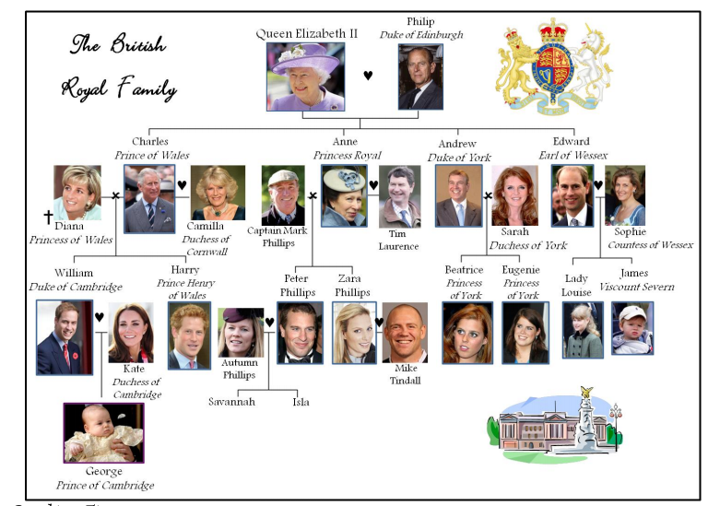

Elizabeth married Philip. Elizabeth is Philip's wife and Philip is Elizabeth's husband. They had four children - three sons and a daughter – namely Charles, Anne, Andrew and Edward. Charles is Andrew's brother and Anne is Andrew's sister. Their parents are called Elizabeth and Philip. Elizabeth is their mother and Philip is their father.
Charles married Diana. Anne married Mark. Andrew married Sarah. Edward married Sophie. Charles and Diana had two sons, William and Harry. Anne and Mark had a son and a daughter, Peter and Zara. Andrew and Sarah had two daughters, Beatrice and Eugenie. William and Beatrice are cousins. Charles is Beatrice's uncle and Anne is William's aunt. Andrew has Harry and a niece called Zara. So Elizabeth and Philip have six grandchildren - three grand granddaughters. Elizabeth is their grandmother and Philip is their grandfather.

Who is who?
1 Charles is William's…
2 Elizabeth Is Zara's…
3 Philip is Elizabeth's…
4 Beatrice is Edward's…
5 Harry is Charles'…
6 Anne is Beatrice's…
7 William is Peter's…
8 Eugenie is Philip's…
9 Sarah is Beatrice's…
10 Eugenie is Sarah's…
11 Philip is Harry's…
12 Zara is Peter's…
13 Edward is Andrew's…
14 Elizabeth and Philip are Beatrice's…
15 Andrew is William's…
16 Peter is Elizabeth's…
17 Philip has four…
18 Harry is Anne's…
19 Elizabeth is Philip's…
20 Elizabeth has six…
21 Elizabeth and Philip are Edward's…

Question Time
- Who is Elizabeth's husband ?How many sons does Elizabeth have ?
- What are their names ?
- Elizabeth has a daughter, what's her name ?
- How many grandchildren does Elizabeth have ?
- How many great-grandchildren does she have ?
- Who is William's mother ?
- She died in a car crash in 1997, do you know where ?

Guessing Time
- 1. He is the future King, he married twice, he has two sons : ………………………
- 2. William is her grandson : ……………………………………
- 3. She is William' s wife : …………………………………
- 4. His sister-in-law is called Kate : ………………………………………

III. ACTIVITIES.

Family Wordsearch
Find 16 words on our topic.

What’s missing?
B | F | A | U | V | E | S | I | J | X | Y | I | P
U | T | M | I | L | H | W | S | X | A | U | Y | A
N | S | T | R | Y | E | G | T | E | R | N | B | R
C | L | E | S | C | D | C | F | V | W | T | Z | E
J | K | L | D | O | I | O | U | S | I | N | H | N
A | N | M | A | U | G | A | F | N | A | B | Z | T
S | O | N | X | Y | H | R | C | K | M | E | C | S
N | P | P | Q | D | T | O | Q | N | I | H | Y | L
E | P | H | E | W | E | R | G | N | E | C | E | M

MALE | FEMALE
son
 | sister
father
 | grandmother
nephew
 | wife
uncle
 | Mother-in-law
Brother-in-law
 | stepmother
godfather

Family word scramble
1. ehfrta________________
2. mehtor________________
3. hobrrte________________
4. ons________________
5. tuhgdaer________________
6. rseits________________
7. nuecl________________
8. tuan________________
9. gandetohrrm________________
10. scunoi________________
11. maeirdr________________
12. fiew________________
13. dsbahun________________
14. dntgarfehra________________
15. famiyl________________

Susan is Ian’s penfriend. Read this letter and complete the gaps with the verb “to be” or “have got”:

Hi Ian!
How are you?
I ________Susan Silva and this ________ my family. I ________ten years old. I ________a baby brother. He _________ three years old. And his name ________ Pedro. We _____from Albufeira. A city in the Agarve. So we ______ Portuguese.
My parents ________José and Amélia. My father _______ a reporter and he is 37. He is tall and thin. He _____ brown hair and blue eyes. He _______ a small mouth and nose. He works very hard. My mother ______ 34 years old and she _______ a teacher at a secondary school , here in Albufeira. She ______very nice an friendly. She ______ blue eyes and short, brown hair.
Pedro _____ short and a bit plump. He ________ short, straight and red hair. He _______ some freckles. He loves playing with his cars and likes drawing animals. Sometimes he _________ a bit stubborn.
Natasha ______ our tiny cat. It _____quite smart and active.
I _______ slim and tall for my age. I _______ blonde hair and blue eyes like my father. I _______ nice and very curious. I love sciences and I ______ good student. My favourite hobbies _______ riding my bike, playing basketball and reading.
When we ______ together, we like camping and travelling. We ______a very happy family.
Write to me soon!
Susan.

Fill in your family tree.

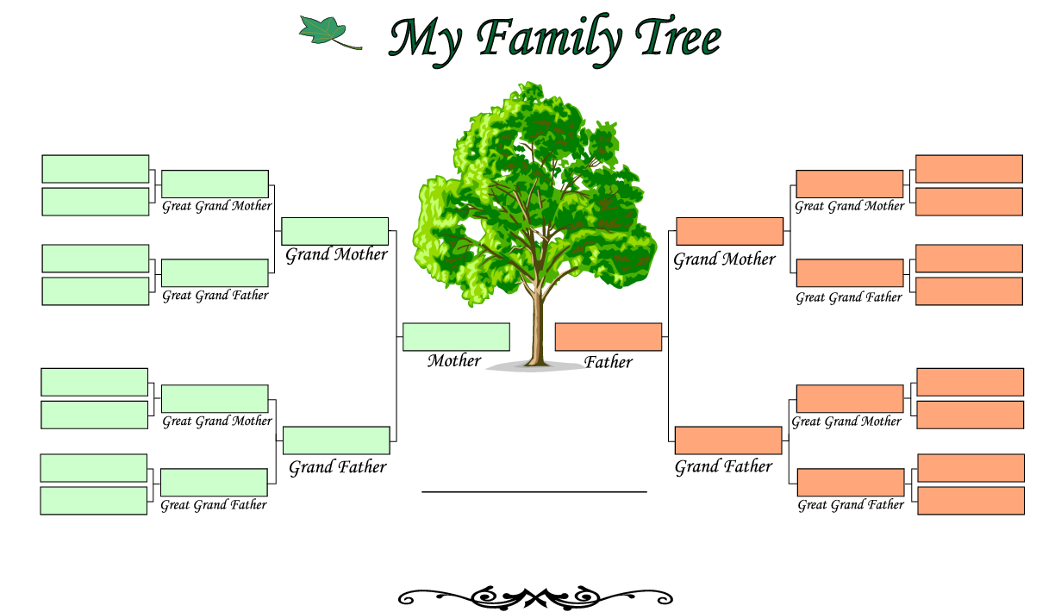

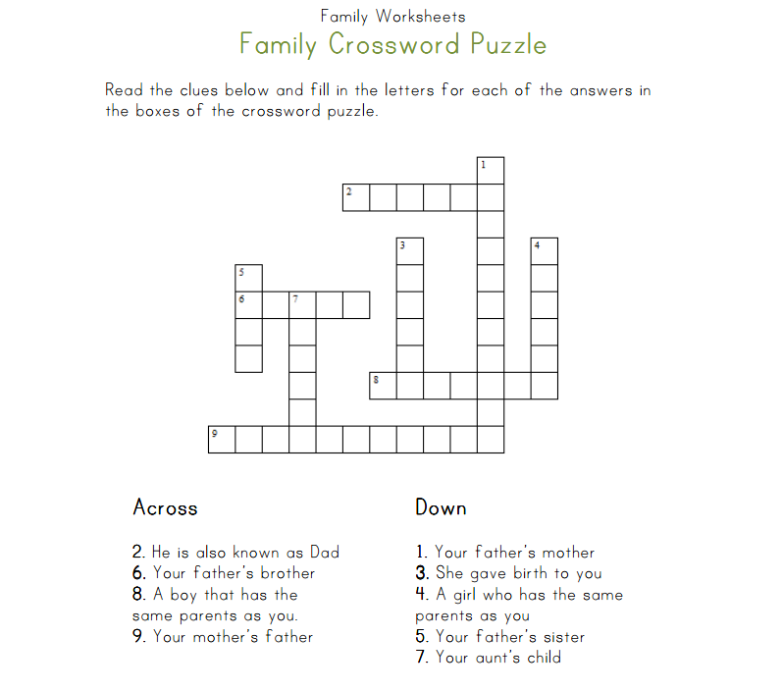

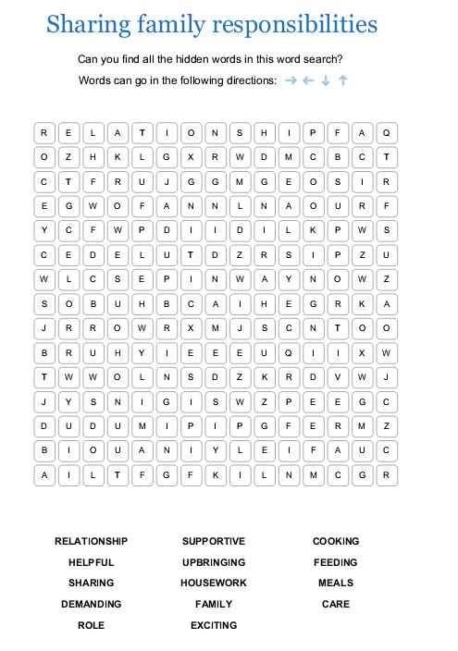

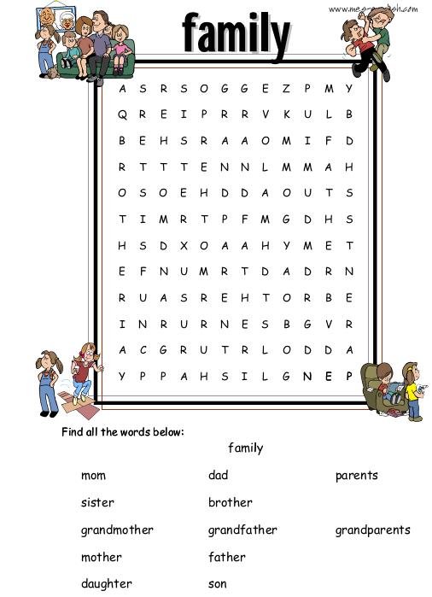

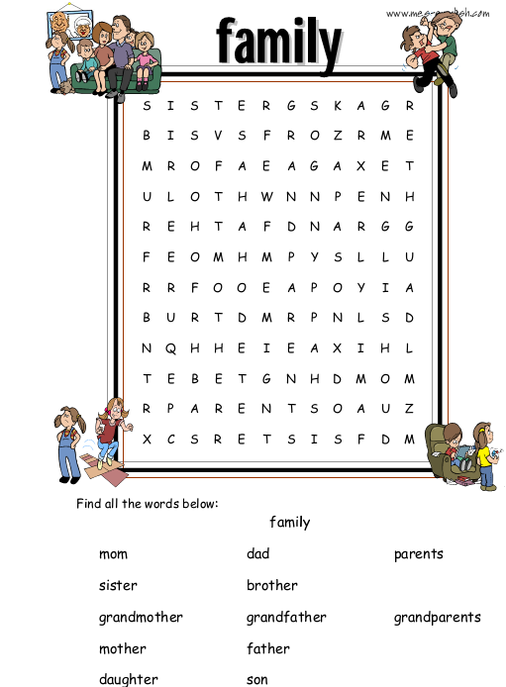

IV. TEST YOURSELF!

My Family and I
I

- Раскройте скобки, заменяя русские слова на английские.

My _________(имя) is Lena. My _________ (фамилия) is Kotova. I live with my _________(родители). I study at college. My _________’s (отец) ___________(имя) is Viktor Nikolaevitch. He is ________(40) years old. He is tall. My ___________(отец) is a worker. My ____________’s (мать) __________(имя) is Vera Ivanovna. She is ____________________(того же возраста). She is a doctor.
My ________ (мать) has a __________(сестра). Her ___________(имя) is Olga. She is my _________(тетя). She has a ____________ (муж). His __________(имя) is Oleg. He is my ____________(дядя). I am their _____________(племянница). They have a ________(сын), Sergei and a _________(дочь), Anna. They are my __________(кузены). Anna is a _________(племянница) of my _________(мать) and Sergei is a ______________(племянник) of my _________(мать).
They ____________(близнецы) and look very much alike. My _________ (мать) and_________(тетя) have ___________(родители). Their __________(мать) Nina Petrovna and their __________(отец) is Ivan Andreevich. They are my _____________(бабушка) and ___________(дедушка). They are ____________(пожилые). My ______________(отец) has only a ________________(мачеха). She is a good woman. Our family ______________(родом из) Russia. My _______________(место рождения) is Bryansk. I love my _________________(семья) and I love my _______________(родной) city.

- Найдите в кроссворде еще16 слов по теме: My Family and I
N | A | B | E | A | U | C | D | C | G | R | A | D | F | C | B | G
Z | M | E | S | A | N | N | I | O | N | A | N | N | Y | E | I | Z
I | C | Y | F | K | T | E | H | U | M | F | A | T | X | B | R | F
S | J | D | N | E | O | P | O | S | E | U | L | H | G | M | T | W
U | R | N | A | M | E | H | N | I | K | N | I | E | R | H | H | L
I | S | T | E | R | S | E | I | N | Q | C | L | E | G | Y | D | O
S | R | H | A | G | E | W | E | C | E | P | U | J | K | L | A | X
G | B | R | Q | T | T | P | M | O | T | H | E | R | V | K | Y | M
P | R | O | T | H | T | B | S | I | N | S | U | N | A | T | I | W
Q | V | U | X | E | R | A | T | W | V | M | A | R | R | Y | V | E

- __birthday_______________
- ____________________________
- ____________________________
- ____________________________
- ____________________________
- ____________________________
- ____________________________
- _____________________________
- _____________________________
- _____________________________
- _____________________________
- _____________________________
- _____________________________
- _____________________________
- _____________________________
- _____________________________
- ______________________________

- Заполните кроссворд подходящими словами из темы My Family and I:

F
A
M
I
L
Y
L
I
F
E

- Вставьте нужный глагол to be

- Ann and Mark ___ from Manchester.
- We ___ very good doctors.
- Mr and Mrs Baker ___ on a trip to the USA to visit their cousin Anne
- Hamburg ___ a city in Germany.
- Manchester and London ___ cities in England.
- I ___ a football fan.
- It ___ Sunday today
- His life _____interesting.
- She _____at the open window.
- What time ___ it?

My Family and I
II

- Раскройте скобки, заменяя русские слова на английские.

My _________(имя) is Alex. My _________ (фамилия) is Sokolov. My __________(прозвище) is Sokol. I have a _____________(брат), Oleg. We are ______________(одного возраста) and we are ___________(близнецы). It is funny to celebrate ________________(день рождения) on the same day. Our __________ (родители) are good. Our ____________(мама) Olga Ivanona is a teacher and our ___________(отец) Vadim Petrovich is an engineer. They are from Belarus and they are _________________(соотечественники). Russia is our ___________ (родная) country and Bryansk is our ___________________(место рождения). My ___________(отец) has a ___________(брат) Andrey. He is our __________(дядя). He is not married and he has no ______________(дети). Our ____________(мать) has a ____________(сестра), Helen. She is our ___________(тетя). And we are her___________(племянники). She has two ______________(дочери). They are our ____________(кузины).
Our ___________ (мать) and ___________(отец) have _______________(родители). They are our ______________(бабушки и дедушки). Our _______________(бабушки) are very kind and our ______________(дедушки) are very clever. We love our _____________(семья).

- Найдите в кроссворде еще16 слов по теме: My Family and I
B | A | H | B | C | B | O | P | A | R | E | N | A | D | E | F | D | A
I | G | U | H | I | J | R | K | N | L | C | T | U | M | G | R | N | U
R | O | S | B | A | N | N | P | A | Q | O | S | N | T | S | A | N | G
T | S | U | V | W | D | X | Y | M | E | U | S | I | C | O | T | N | H
H | O | N | F | D | A | D | N | I | Z | A | B | N | C | M | E | Y | T
P | L | A | C | E | U | D | G | E | C | E | I | W | L | N | O | P | E
C | B | A | Z | Y | N | X | Y | H | M | K | J | I | F | E | S | Q | R
T | W | I | N | S | C | L | E | W | A | R | R | Y | M | K | T | U | V

- _come_______________
- ___________________________
- ____________________________
- ____________________________
- ____________________________
- ____________________________
- ____________________________
- _____________________________
- _____________________________
- _____________________________
- _____________________________
- _____________________________
- _____________________________
- _____________________________
- _____________________________
- _____________________________
- ______________________________

- Заполните кроссворд подходящими словами из темы My Family and I:
M
E
&
M
Y
F
A
M
I
L
Y

- Вставьте нужный глагол to be

- Frank ___ from France.
- It ___ not my dog.
- My mother and my sister ... laughing.
- He ... a teacher of languages.
- The hamster ___ in the cage.
- Trixi and Susi ___ my cats.
- Peter Baker ___ from Manchester.
- These girls ___ beautiful.
- His name ___ Charles.
- I ___ married with two children.

Список литературы:

- Голицынский Ю.Б. Spoken English Пособие по разговорной речи. – СПб.: КАРО, 2012 – 416
- Дроздова Т.Ю. Everyday English: учебное пособие. – 7-е изд. – СПб.: Антолгия, 2009 – 592 с.
- Дудорова Э. С. Практический курс разговорного английского языка: Учебное пособие. – СПб.: Перспектива, 2012. – 344 с.
- Falla T. Solutions Elementary: Student's Book. - Oxford University Press, 2008– 138 с.
- Soars J., Soars L. New Headway: Elementary Student's Book. - Oxford University Press, 2013 – 160 с.

Список интернет-источников:

- http://busyteacher.org/classroom_activities-vocabulary/familyfriends-worksheets/
- https://en.islcollective.com/resources/search_result?Vocabulary_Focus=Sports&page=3
- http://www.eslprintables.com/
- http://www.mes-english.com/worksheets/flashcards/classroom.php

